**CampHire**

**A PROJECT REPORT**

**for Project (KCA451) Session (2024-25)**

**Submitted by**

**Harshit Shekhar**

### (2300290140073)

**Harsh Chaudhary**

### (2300290140067)

**Piyush Pratap Singh**

### (2300290140116)

**Submitted in partial fulfilment of the Requirements for the Degree of**

MASTER OF COMPUTER APPLICATION

**Under the Supervision of Dr. Akash Rajak (Professor)**



**Submitted to**

**Department Of Computer Applications**

**KIET Group of Institutions, Ghaziabad Uttar Pradesh-201206**

**(APRIL 2025)**

**CERTIFICATE**

Certified that **Harshit Shekhar 2300290140073, Piyush Pratap Singh 2300290140116, Harsh Chaudhary 2300290140067,** have carried out the project work having **“CampHire” (Project- KCA451)** for **Master of Computer Application** from Dr. A.P.J. Abdul Kalam Technical University (AKTU) (formerly UPTU), Lucknow under my supervision. The project report embodies original work, and studies are carried out by the student himself and the contents of the project report do not form the basis for the award of any other degree to the candidate or to anybody else from this or any other University/Institution.

This is to certify that the above statement made by the candidate is correct to the best of my knowledge.

Date:

### Dr. Akash Rajak

### Dean- MCA

### Department of Computer Applications

### KIET Group of Institutions, Ghaziabad

**ABSTRACT**

**CampHire** is a MERN Stack-based job portal designed to streamline campus recruitment by connecting students with potential employers through a secure, skill-based digital platform. The project facilitates a structured hiring process where **employers can register, post job listings, and evaluate applicants**, while **students can sign up, build profiles, apply to jobs, and take assessments using Neo Platform** to qualify for further rounds.

The platform emphasizes **equal opportunity and merit-based hiring**, aligning with the principles of **Sustainable Development Goals (SDG 4 – Quality Education and SDG 8 – Decent Work and Economic Growth)**

With secure authentication via JWT and bcrypt, efficient data handling through MongoDB, and a user-friendly interface built with React, CampHire ensures a smooth experience for both employers and students.

By promoting a transparent, interactive, and efficient recruitment environment, CampHire not only prepares students for the workforce but also empowers recruiters to discover and hire the most suitable candidates from academic institutions.

**ACKNOWLEDGEMENTS**

Success in life is never attained single-handedly. My deepest gratitude goes to my project supervisor, **Dr. Akash Rajak** for her guidance, help, and encouragement throughout my project work. Their enlightening ideas, comments, and suggestions.

Words are not enough to express my gratitude to **Dr. Akash Rajak**, Professor and Dean, Department of Computer Applications, for his insightful comments and administrative help on various occasions.

Fortunately, I have many understanding friends, who have helped me a lot on many critical conditions.

Finally, my sincere thanks go to my family members and all those who have directly and indirectly provided me with moral support and other kind of help. Without their support, completion of this work would not have been possible in time. They keep my life filled with enjoyment and happiness.

### Harshit Shekhar (2300290140073)

### Piyush Pratap Singh (2300290140116)

### Harsh Chaudhary (2300290140067)

**TABLE OF CONTENTS**

|  |  |
| --- | --- |
| Certificate | ii |
| Abstract | iii |
| Acknowledgements | iv |
| Table of Contents | v |
| List of Tables | vii |
| List of Figures | viii |
| 1 Introduction | 1 |
| 1.1 Project Description | 1 |
| 1.2 Problem Statement | 3 |
| 1.3 Objective | 4 |
| 1.4 Feasibility Study | 5 |
| 1.4.1 Technical Feasibility | 5 |
| 1.4.2 Operational Feasibility | 6 |
| 1.4.3 Economic Feasibility | 6 |
| 1.5 Scope of the project | 8 |
| 1.6 Methodology | 8 |
| 2 Literature Review | 9 |
| 2.1 Related Work | 9 |
| 2.2 Limitations of Existing Systems | 10 |
| 2.3 Research Gap | 10 |
| 3 System Analysis and Design | 12 |
| 3.1 Requirement Analysis | 12 |
| 3.2 Software/Hardware Requirements | 14 |
| 3.3 Data Flow Diagram (DFDs) | 16 |

* 1. Frontend Architecture 19
  2. Backend Architecture 20
  3. ER Diagrams / UML 23

1. Implementation 25
   1. Technology Stack 25
   2. Frontend Design 26
   3. Backend Implementation 26
   4. Database Design 27
   5. Modules 29
2. Testing and Evaluation 30
   1. Introduction 30
   2. Types of Testing 31
   3. Test Plan 31
   4. Test Cases 31
   5. Result of the Evaluation 32
   6. Conclusion of testing results 32
   7. Summary 33
3. Results and Discussion 35
   1. Output Screenshots 35
   2. Observation 39
   3. Discussion 40

Conclusion 42

Future Scope and Further Enhancement of the Project 44

Bibliography 45

**LIST OF TABLES**

|  |  |  |
| --- | --- | --- |
| **Table No.** | **Name of Table** | **Page** |
| 4.4.1 | User Schema | 27 |
| 4.4.2 | Code Schema | 28 |
| 4.4.3 | Room Schema | 28 |
| 5.4 | Test Cases | 32 |
| 5.5 | Test Cases Description | 32 |

**LIST OF FIGURES**

|  |  |  |
| --- | --- | --- |
| **Figure No.** | **Name of Figure** | **Page No.** |
| 3.3 | 0-Level DFD | 17 |
| 3.3 | 1-Level DFD | 18 |
| 3.6 | ER Diagram | 23 |
| 4.1 | MERN Stack Overview | 25 |
| 6.1 | Dashboard | 35 |
| 6.2 | Login | 35 |
| 6.3 | Signup | 36 |
| 6.4 | Code-Editor | 36 |
| 6.5 | Run and save | 37 |
| 6.6 | Output | 37 |
| 6.7 | Saved Code | 38 |
| 6.8 | Light mode | 38 |

viii

**CHAPTER – 1**

**INTRODUCTION**

* 1. **Project Description**

**CampHire** is a web-based job portal designed specifically for academic institutions to streamline the campus recruitment process. Developed using the **MERN Stack (MongoDB, Express.js, React.js, Node.js)**, CampHire connects students with recruiters in a secure and structured environment where job applications and hiring decisions can be managed efficiently.

The platform allows **employers to register and post job openings**, while **students can create accounts using verified college credentials and apply to relevant roles**. To further aid in candidate evaluation, **students are redirected to the Neo Platform to complete assessments**, after which recruiters can review the applicants and make informed decisions.

CampHire incorporates essential features such as:

* **Secure Registration**: Access restricted to verified college students for a safe and trusted environment.
* **Job Posting System**: Employers can add and manage multiple job listings.
* **Application Tracking**: Recruiters can view applicants, review details, and shortlist candidates based on their submissions.
* **Email Notifications**: Automated email updates inform students about changes in their application status and notify employers of new applicants.

**Use Case Highlights:**

➤ **For Students**: Simplifies the job search process and connects them with verified employers through a centralized portal.  
➤ **For Recruiters**: Provides easy access to student profiles and facilitates transparent application management.  
  
➤ **For Institutions**: Enhances the placement process by offering a unified platform for job postings and student engagement.

Aligned with **SDG Goal 4 (Quality Education)** and **SDG Goal 8 (Decent Work and Economic Growth)**, CampHire ensures that students receive equal access to employment opportunities while promoting skill-based evaluations via external platforms like Neo.

.

* 1. **Problem Statement**

Designing a job portal specifically tailored for academic institutions presents a range of challenges that must be addressed to ensure effective, secure, and streamlined recruitment for both students and employers. At the heart of the problem lies the **need for a centralized, college-specific platform** that bridges the gap between students seeking internships or full-time roles and recruiters offering verified opportunities.

A major challenge in traditional campus hiring is the **lack of a unified system** where students can find relevant job postings and recruiters can manage applicants effectively. Current solutions are often fragmented, rely heavily on manual processes, or expose students to potentially unverified job listings on third-party sites. CampHire tackles these issues by providing a **closed and secure ecosystem**, where **only verified college students and registered employers can interact**.

The platform architecture must support robust **authentication and authorization systems** to validate college IDs and ensure only eligible users gain access. This is crucial to maintain the integrity of the application process and to build trust among stakeholders. CampHire implements token-based authentication mechanisms (like JWT) to manage secure sessions and prevent unauthorized access.

Job posting and application tracking are essential components of the system. The platform must allow employers to seamlessly create, edit, and remove job listings while also offering a structured workflow for reviewing applications. For students, the challenge is to provide an intuitive and responsive interface where they can apply for roles and monitor their application status. **Real-time status updates via email notifications** help keep users engaged and informed, reducing miscommunication.

Given that assessments are conducted externally via platforms such as **Neo**, the system must include efficient redirect and result integration mechanisms, ensuring a cohesive user experience without duplicating test infrastructure. This separation also helps reduce the system's internal complexity and enhances maintainability.

Scalability and performance optimization are also critical considerations. The platform must support multiple concurrent users during peak hiring seasons without degradation in response time. Efficient database operations, query optimization, and indexing play a key role in maintaining system performance under load.

CampHire, by focusing on these critical problem areas, offers a tailored and institution-centric solution that enhances the hiring experience for both students and employers. It reduces friction in the placement process, brings transparency to hiring decisions, and sets the foundation for future enhancements aligned with academic and industry needs.

**1.3- Objective**

### Real-Time Collaboration:

To provide employers with an intuitive platform to post job openings and manage applications efficiently, while enabling students to apply to relevant opportunities in a few simple

**2. Secure Authentication and Access Control:**  
To restrict access to verified students and registered employers through college ID verification and robust login mechanisms using JWT and bcrypt for secure sessions.

**3.Centralized Candidate Review System:**  
To empower employers with the ability to view, filter, and shortlist applicants within a single dashboard, streamlining candidate evaluation.

**4. Integration with External Assessment Platforms:**  
To redirect students to external platforms like Neo for test-taking and ensure a cohesive application experience without overloading the internal system.

**5. Real-Time Notification System:**  
To implement email notifications for both students and employers, updating them about application status changes, new applicants, or job postings to improve engagement.

**6. Data Privacy and Protection:**  
To ensure the privacy and integrity of user data through secure data handling practices, encrypted storage, and restricted access protocols.

**7. User-Friendly Interface and Navigation:**  
To design a modern, responsive, and accessible interface that simplifies navigation and enhances the user experience for both employers and students.

**8. Scalability and Maintainability:**  
To build a scalable architecture using the MERN stack that can support increasing users and job listings while being easy to maintain and extend in the future.

**1.4- Feasibility Study**

A feasibility study is an essential step in the early stages of a software project. It assesses whether the proposed system can be developed and implemented successfully within existing constraints such as  
time, technology, budget, and manpower. The goal is to determine the viability of *CampHire*—  
a campus recruitment platform developed using the MERN stack—by evaluating its technical,  
operational, and economic aspects. This analysis helps ensure that the project's goals are achievable, sustainable, and beneficial to its target users.

**1.4.1-Technical Feasibility**

The technical feasibility of **CampHire** is highly promising due to the maturity and wide adoption of the **MERN stack** (MongoDB, Express.js, React.js, Node.js). These technologies offer robust scalability, modularity, and flexibility—making them suitable for building modern web applications.

**Frontend:** Built using React.js, enhanced with Tailwind CSS or Bootstrap for responsive and accessible UI components.

**Backend:** Node.js and Express.js form the RESTful API layer, enabling seamless interaction with the frontend and database.

**Database:** MongoDB Atlas stores structured data like users, job posts, and applications using flexible schema design through Mongoose ODM

**Authentication:** Implemented using **bcrypt** for password hashing and **JWT (JSON Web Tokens)** for secure session handling.

**Email Notifications:** Handled using **Nodemailer**, ensuring timely communication between students and employers.

**Security:** Enforced through SSL, input validation, token-based auth, and access control for student/employer roles.

The current architecture is easily extensible, allowing future integration of AI-based job matching, resume analysis, or custom assessments—all of which validate the project's technical sustainability.

### 1.4.2- Operational Feasibility:

Operationally, **CampHire** is designed to provide a seamless and intuitive experience for both students and recruiters. The platform addresses core campus placement requirements and streamlines the job application process

**User Roles:** Clear distinction between students and employers ensures task-focused interaction with the system.

**Job Management:** Employers can efficiently post, update, and review job applications, while students can view and apply to listings in real-time.

**Assessment Integration:** External support from the Neo platform allows quick integration of assessments without building an internal test engine.

**Email Alerts:** Automated notifications enhance user engagement and ensure timely action from both parties.process.

**User Interface:** The UI is designed for accessibility and simplicity, catering to both tech-savvy and non-technical users.

Operational success will be supported by continuous monitoring, user feedback loops, regular maintenance, and planned enhancements based on user demands. The system is expected to scale smoothly across various institutions and user bases.

### 1.4.3- Economic Feasibility:

The economic feasibility of CampHire is well justified given the controlled development environment and open-source tech stack. The primary cost drivers include:

**Initial Development:** Minimal cost due to student-led development using free tools and cloud-tier services.

**Infrastructure:** Hosting via Render or Vercel offers generous free tiers for backend and frontend hosting during the development and early testing phases.

**Third-party Services:** Neo platform assessments and email services are either free for basic use or cost-efficient at scale.

**Long-term Economic Benefits:**

* CampHire has potential for **monetization** via premium features (e.g., AI-based   
  recommendations, skill analytics).
* **Institutional Licensing:** Colleges can adopt it as their official placement portal.
* **Scalability:** Operational costs will grow linearly, but user and data value will grow   
  exponentially, improving ROI.

As demand for centralized, digital campus placement tools increases, CampHire stands out   
as a scalable and cost-efficient solution aligned with SDG Goals 4 & 8 (Quality Education &   
Decent Work).

### Key features:

1. **Real-time Application Updates**  
    Provides instant updates on job application statuses, interview calls, and recruiter feedback to ensure smooth and timely communication between students and employers.
2. **Customizable Job Posting Interface**  
    Employers can easily create detailed job posts with custom fields like role descriptions, skill requirements, salary range, and deadlines to streamline hiring.
3. **Role-based Access Control**  
   Offers distinct dashboards and features for students and employers, ensuring focused and organized interactions for each user type.
4. **Job Application Management**  
    Allows students to apply for jobs with one click and view application history, while recruiters can track, filter, and manage applicants for each job posting.
5. **Application History & Tracking**  
    Maintains a history of all applications and their status updates, enabling students and recruiters to keep track of every stage of the hiring process.
6. **Secure User Authentication**  
    Incorporates JWT and bcrypt for robust login security, ensuring only verified users access the platform and their personal data is protected.
7. **User-Friendly Interface**  
    Designed with a clean and responsive UI using React and Tailwind CSS, offering seamless navigation and accessibility for all users.
8. **Scalable & Integrable Architecture**  
    Built for growth with support for future integrations such as internal assessments, resume uploads, and skill-based candidate filtering.

**1.5- Scope of the Project**

The purpose of **CampHire** is to streamline and digitalize the campus hiring process by providing a centralized platform that connects students and employers. The current recruitment process often involves scattered communication, delayed notifications, and manual resume sorting, leading to inefficiencies for both students and recruiters.

**CampHire** aims to solve these issues by introducing a structured, intuitive system where job postings, applications, and communication are handled seamlessly.

The platform was built with the following objectives in mind:

1. **To simplify campus recruitment:**  
   CampHire enables employers to post jobs and manage applicants in one place, while students can view, filter, and apply to jobs that match their skills — all on a single platform.
2. **To ensure structured communication:**  
   By integrating automated email notifications for job status changes and new applicants, CampHire removes the dependency on external messaging and ensures that both parties stay updated throughout the hiring process.
3. **To support academic integrity:**  
   The platform ensures that only verified students (with official college IDs) can register, maintaining a secure and exclusive environment for genuine job seekers and employers.
4. **To facilitate assessment integration:**  
   Although CampHire does not provide its own testing platform, it supports smooth redirection to third-party systems like the **Neo Platform** for conducting assessments, ensuring a consistent workflow for skill evaluation.
5. **To encourage profile development:**  
   Students can build detailed profiles with educational background and skills, helping recruiters make informed decisions — even without full portfolio uploads or skill match analytics.

**1.6- Methodology**

The development of **CampHire** follows a modular and agile approach to ensure flexibility, scalability, and rapid delivery of features. The project has been implemented using the **MERN Stack** (MongoDB, ExpressJS, ReactJS, NodeJS), allowing for end-to-end JavaScript development and seamless integration between frontend and backend systems.

**1. Requirement Analysis**

* Identified pain points in the traditional campus recruitment process through research and student-employer interviews.
* Collected functional and non-functional requirements.
* Defined clear objectives: job posting, student applications, employer review, assessment redirection, and status updates.

**2. System Design**

* Designed Entity-Relationship (ER) diagrams to map data relationships.
* Created wireframes and UI mockups for the user interface.
* Planned system architecture based on client-server communication using RESTful APIs.

**3. Frontend Development**

* Built using **React.js** for dynamic rendering and a responsive UI.
* Implemented routing with **React Router**.
* Used Redux/Context for state management to handle authentication and job listing data.

**4. Backend Development**

* Developed APIs using **Node.js** and **Express.js**.
* Secured API endpoints with JWT (JSON Web Token) authentication and bcrypt password hashing.
* Configured roles and permissions for Students and Employers.

**5. Database Integration**

* Used **MongoDB** as the NoSQL database to store user data, job listings, and application statuses.
* Implemented Mongoose schemas to maintain structured data models.

**6. Assessment Integration**

* Integrated redirection to **Neo Platform** for conducting technical assessments externally.
* Stored assessment status and links in the database for employer reference.

**7. Notification System**

* Configured automatic **email notifications** for:
  + Job application submission
  + Job status updates
  + New applicant alerts for employers

**8. Testing and Validation**

* Performed unit testing for API routes.
* Conducted frontend validation using form libraries.
* Tested across devices and browsers for responsiveness and compatibility.

**9. Deployment**

* Frontend deployed on **Vercel**.
* Backend and database hosted on **Render** or **MongoDB Atlas** respectively.
* Environment variables managed securely for deployment.

**10. Maintenance and Feedback**

* Collected user feedback from test users (students and employers).
* Scheduled regular updates and performance optimizations.
* Iterative improvements added in small development sprints.

**CHAPTER-2**

**Literature Review**

The rapid digitalization of recruitment processes and the increasing reliance on remote hiring have led to the emergence of several web-based job portals and campus recruitment platforms. These platforms are designed to streamline interactions between students and employers by enabling online job postings, applications, shortlisting, and communication — all within a centralized browser-based environment.

While existing platforms like LinkedIn, Internshala, and college-specific ERP systems offer partial solutions, they often fall short in addressing the unique needs of campus hiring. Key limitations include a lack of student verification mechanisms, absence of real-time application tracking, limited employer engagement features, and minimal integration with skill assessments.

This chapter critically examines the existing platforms, highlights their functional gaps, and defines the research and development opportunities that **CampHire** is designed to fulfill. By offering a verified, student-first job portal tailored for campus recruitment, CampHire bridges the gap between institutions and industries through a more secure, intuitive, and feature-rich hiring ecosystem.

* 1. **Related Work**

Several modern platforms have established themselves in the campus recruitment and job portal space. Some of the most widely used solutions include **LinkedIn**, **Internshala**, **Naukri.com**, **Superset**, and **Handshake.**

**LinkedIn**: A global professional networking platform that allows job seekers and recruiters to connect. While it offers powerful networking and job-posting tools, it's not tailored for student verification or campus-specific hiring processes.

**Internshala**: A popular platform for internships and fresher jobs. It focuses on early-career opportunities but lacks integration with college systems and doesn't offer real-time application status tracking or assessments.

**Naukri.com**: One of India’s largest job portals, mainly designed for experienced professionals. It lacks features like college-level verification or skill-based shortlisting tailored to fresh graduates.

**Superset**: Designed specifically for campus placements, Superset connects colleges with recruiters. However, it can be complex and expensive to implement, with limited customization for smaller institutions.

**Handshake**: A platform widely used in U.S. universities to connect students with employers. It offers verified access and job matching but is largely inaccessible or underutilized in the Indian education ecosystem.

These platforms have contributed significantly to digitizing recruitment, yet most fall short in offering a **lightweight, customizable, and student-first solution**. **CampHire** aims to bridge this gap by providing a platform specifically built for verified students and recruiters, featuring job applications, assessment integration, and real-time communication — all optimized for campus hiring needs.

* 1. **Limitations of Existing Job Portal Platforms**

Despite their usefulness, current job portal and campus recruitment platforms come with several limitations that reduce their effectiveness in college-specific or student-centric hiring scenarios.

* + - **Lack of College Verification**  
      Most platforms do not support college ID-based verification, which makes it difficult to ensure that only genuine students and verified recruiters participate in the hiring process.
    - **Complex and Costly Setup**  
      Enterprise platforms like Superset or Handshake often involve complex onboarding, institutional contracts, and higher costs — making them less accessible for small colleges or individual student users.
    - **Limited Real-Time Updates**  
      Many existing systems lack real-time notifications or status tracking for job applications, leading to communication gaps between students and employers.
    - **No Integrated Assessments**  
      While some platforms allow for job applications, they rarely integrate external assessment tools or testing workflows, requiring recruiters to manage tests on separate systems.
    - **Minimal Customization**  
      Most platforms follow a rigid structure and don’t allow customization of job postings, student profiles, or filtering based on specific campus-related criteria.
    - **Limited User Roles & Access Control**  
      Role-based views are often missing or underdeveloped, making it hard to separate functionalities for recruiters, placement officers, and students in a structured way.
    - **No Skill-Based Shortlisting**  
      There is little to no support for filtering or ranking candidates based on relevant skills, certifications, or matched job criteria.

These shortcomings highlight the need for a platform like **CampHire**, which is designed to offer a **simple, customizable, and student-first solution**, built specifically for **campus recruitment needs**.

* 1. **Research Gap**

A review of existing job portals and campus recruitment platforms reveals a clear gap in functionality and accessibility, especially for college-level recruitment scenarios. While platforms like Naukri, LinkedIn, and Handshake offer robust hiring solutions, they often fall short in areas that matter most for student communities and academic institutions.

**Key missing elements in existing systems include:**

* Lack of **college ID-based registration and verification** for genuine student access
* No support for **real-time application tracking or recruiter-student interaction**
* Absence of **assessment tool integration** for skill evaluation
* Limited or no **customization in job posting filters and dashboards**
* Inadequate **role-based access control** for different user types like recruiters, students, and placement officers
* Missing features for **email notifications, interview updates, or progress alerts**
* Lack of **student-focused UI/UX**, making them less user-friendly for first-time job seekers

This These limitations reveal a strong need for a solution tailored to the **college recruitment ecosystem**.

### CampHire Bridges the Gap

CampHire is designed to fill this void by providing:

* Verified user onboarding using college ID-based sign-up
* Real-time job application updates and recruiter alerts
* Integration with external assessment platforms like Neo for skill testing
* Personalized dashboards for students and recruiters
* Secure authentication with JWT and bcrypt
* Email notification system for application status and job alerts
* Scalable and modular architecture for future features like resume uploads and skill match filter

By addressing these unmet needs, **CampHire creates a lightweight, user-friendly, and purpose-built recruitment platform** that bridges the gap between professional job portals and the specific needs of college campuses.

**CHAPTER -3**

**System Analysis and Design**

The design of **CampHire** is guided by the goal of building a streamlined, secure, and user-friendly job portal tailored specifically for college students and recruiters. With the growing demand for digital recruitment and campus placement automation, CampHire addresses the need for a centralized platform that enables job posting, application tracking, and recruiter-student interaction in real-time.

* 1. **Requirement Analysis**

Requirement analysis lays the foundation for the successful development of **CampHire** by identifying user expectations, system capabilities, and technical constraints. This process ensures the platform meets the practical needs of both **students seeking jobs** and **employers offering opportunities**. The analysis involved evaluating similar job portals, collecting student/recruiter feedback, and identifying key features needed for effective campus hiring.

* + 1. **Functional Requirements**

Functional requirements define what **CampHire** must do to serve its users effectively. The platform is designed to provide a smooth, secure, and interactive job application process

### 1. User Registration & Authentication

* Students and employers must register and log in using verified credentials.
* Authentication is handled securely using JWT and password encryption via bcrypt.
* Role-based access is maintained (student, recruiter, admin).

**2. Job Posting & Management**

Employers can post new job listings with details like job title, description, required skills, and deadline.

* Job listings can be edited or deleted by the employer.

#### **3. Student Application System**

* Students can browse available job listings and apply directly.
* Each application is stored along with the student's profile data and status.

#### **4. Application Review & Selection**

* Recruiters can view all applications submitted for a job.
* Recruiters can shortlist or reject candidates based on the provided details.

#### **5. Email Notifications**

* Students are notified via email upon application submission and status updates.
* Recruiters receive email alerts when new applications are submitted.

#### **6. Integration with Neo Platform**

* Students are redirected to Neo for assessments (as the system currently does not include a native test engine).

#### **7. Admin Panel (Future Scope)**

* A dedicated interface for admin users to monitor platform activity, manage users, and ensure compliance.

#### **8. Search and Filter Functionality**

* Students can filter job listings by company, role, location, and skill requirements.
* Employers can filter applications based on qualifications and skills.

#### **9. Profile Management**

* Students can update academic and personal details.
* Employers can manage company information and posted jobs.
  + 1. **Non-Functional Requirements**

Non-functional requirements define how **CampHire** performs under various conditions. These aspects ensure the platform is reliable, secure, and user-friendly for both students and recruiters.

### Performance

CampHire should deliver a smooth and responsive experience. Page loads, job applications, and dashboard interactions must occur within minimal latency, even under heavy usage.

### Scalability

The system must handle hundreds of concurrent users and rooms efficiently. Horizontal scalability is supported using clustered **Node.js** servers and stateless backend services.

### Availability

As a campus hiring tool, uptime is essential during placement seasons. CampHire is hosted on cloud platforms (like Render or Heroku), with health checks and auto-restart mechanisms to maintain high availability.

### Security

Security is vital for handling student data and employer credentials. Measures include:

* JWT-based authentication
* Encrypted passwords with bcrypt
* Role-based access control
* Input validation to prevent XSS and SQL/NoSQL injection attacks

### Usability

The user interface should be clean and intuitive, supporting responsive layouts across laptops, tablets, and mobile devices.

### Maintainability

The system follows a modular codebase structure, separating concerns between frontend, backend, and services. This allows developers to easily update or enhance individual components without affecting the entire system.

### Portability

As a web-based application, CampHire is platform-independent. Users only need an internet connection and a web browser—no downloads or installations are required.

### Reliability and Fault Tolerance

The platform is designed to recover gracefully from failures. In case of network interruptions or server restarts, the system ensures that users can resume where they left off—whether reviewing applications or managing job posts.

* + 1. **User Requirements**

Understanding the needs of CampHire's primary users is essential for designing a solution that adds value. The platform serves two major user groups, each with distinct requirements:

#### **Students and Job Seekers**

* Need a platform that’s easy to use, even for those with minimal technical experience.
* Should be able to register, create profiles, upload resumes, and apply to jobs effortlessly.
* Prefer quick access to job listings, application status, and relevant skill assessments.

#### **Recruiters and Employers**

* Require tools to post job openings, manage applicants, and schedule interviews.
* Should be able to view filtered candidate lists based on criteria like skill, academic background, or assessment scores.
* Need simple dashboards for tracking application pipelines and communication.

From these user roles, key requirements include:

* **No software installation** – the platform should be fully browser-based.
* **User-friendly onboarding** – quick registration and setup for both students and recruiters.
* **Job application management** – seamless job search and application tracking for students.
* **Recruiter dashboards** – to manage postings, shortlist applicants, and review student profiles.
* **Automated communication** – including email notifications and application updates.
* **Secure authentication** – ensuring data privacy and access control for all users.
  1. **Software and Hardware Requirements**

To support the features and performance demands of CampHire, both software and hardware choices must be optimized.

**Software Requirements**

CampHire is built using the **MERN stack** (MongoDB, Express.js, React, Node.js) along with third-party integrations for assessments, email notifications, and cloud deployment.

|  |  |
| --- | --- |
| **Component** | **Technology Used** |
| **Frontend** | HTML, CSS, JavaScript, React |
| **UI Libraries** | Tailwind CSS, React Icons |
| **State Management** | Context API, Redux (if needed) |
| **Backend** | Node.js, Express.js |
| **Database** | MongoDB Atlas (cloud-based) |
| **Authentication** | JWT, bcrypt for password hashing |
| **Email Services** | Nodemailer, Gmail SMTP |
| **Assessments** | Neo Platform API (or custom integration) |
| **Deployment** | Render, Vercel, or Heroku |
| **Version Control** | Git and GitHub |

**Table: Software Requirements**

**3.2.2 Hardware Requirements**

For development, testing, and deployment, the following hardware specifications are recommended:

### Development Machine

* **Processor:** Intel Core i5 / AMD Ryzen 5 or higher
* **RAM:** Minimum 8 GB (16 GB recommended for multitasking and smoother performance)
* **Storage:** SSD with at least 256 GB for faster read/write operations
* **Display:** Full HD (1080p) resolution or higher for better UI/UX development
* **Operating System:** Compatible with Windows, macOS, or Linux (Ubuntu preferred for Node.js environments)

#### **Server Requirements (Cloud Hosted)**

* **Processor:** Minimum 2 vCPUs (scalable as needed)
* **RAM:** Minimum 4 GB (8 GB preferred for production)
* **Storage:** At least 20 GB SSD for application files, logs, and database services
* **Network:** High-speed, low-latency internet for faster request handling and API communication
* **Uptime Monitoring:** Tools like Uptime Robot or Cronjobs configured for regular health checks and downtime alerts
  1. **Data Flow Diagram**

The Data Flow Diagram (DFD) for CampHire visualizes the flow of information between users, the frontend interface, the backend services, and the database. It highlights the various processes involved in the system, such as user registration, career path recommendations, skill assessments, and real-time collaboration. The DFD will help in understanding the interactions between components and how data is processed and transferred throughout the system.

In the DFD, four symbols are used and they are as follows.

* + 1. A square defines a source (originator) or destination of system data.

* + 1. An arrow identifies data flow-data in motion. It is 2a pipeline through which information flows.
    2. A circle or a “bubble “(Some people use an oval bubble) represents a process

that transfers informing data flows into outgoing data flows.

* + 1. An open rectangle is a data store-data at rest, or a temporary repository of data

**Context Level Diagram**

The Context Level Diagram (CLD) provides a high-level view of the Codex system, depicting the major external entities (users, advisors, educational institutions, etc.) and their interactions with the system. It helps to define the boundaries of the system and shows how Codex communicates with external systems, ensuring clarity in system design and integration. The CLD serves as the foundation for more detailed process modeling in the later stages of development.

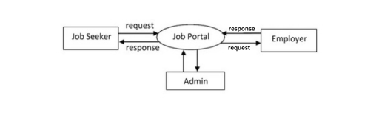

### Fig 3.3 0-Level DFD

The Level 0 Data Flow Diagram (DFD) for Codex provides a high-level representation of the system's core functionality and data interactions. The primary external entities interacting with the system include the users and the database. Users interact with the Codex system by providing inputs such as login credentials, code snippets, and collaboration commands. The Codex system processes these inputs and accesses the database to retrieve or store user-related information, code snippets, and other data. The processed information, such as real-time collaborative changes, saved code, and execution results, is then delivered back to the users. This high-level view showcases how the system acts as a central hub for collaborative coding, code storage, and execution, seamlessly connecting users with the required functionalities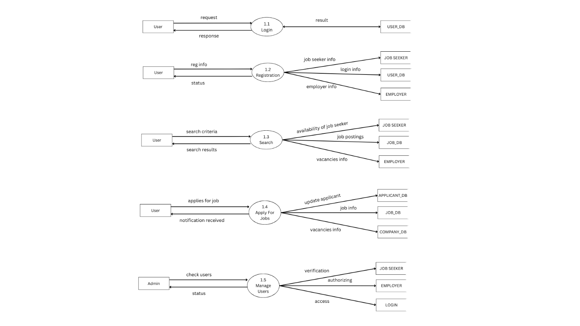

### Fig 3.3 - 1 Level DFD

The Level 1 DFD provides a more detailed breakdown of the processes within Codex. The system begins with **User Authentication**, where users log in or sign up, and their credentials are validated against stored data in the database. Once authenticated, users can access the **Code Editing** functionality. The **Code Saving and Retrieval** process allows users to save their work to the database and retrieve saved code snippets using unique identifiers when needed.

The **Code Execution** process enables users to run their code, which is processed by the backend, and the output is displayed to the users. Furthermore, the **Collaboration** feature facilitates real-time communication and synchronization between users working in the same session, ensuring seamless teamwork. Data is stored and retrieved from two primary repositories: the **User Database** for authentication and profile management and the **Code Repository** for managing code snippets.

## Frontend Architecture

The **frontend architecture** of **CampHire** is designed to be clean, modular, and responsive—offering a seamless and intuitive experience for both students and recruiters. Built using **React**, the interface follows a **component-based architecture**, ensuring maximum code reusability, maintainability, and ease of scaling as new features are added.

### Key Features of Frontend Architecture:

### Component-Based Architecture:

* 1. CampHire uses **React** to build a scalable UI using modular, reusable components. Each major feature—like **job listings**, **user dashboards**, **profile cards**, and **application forms**—is developed as an independent component. This approach ensures clean separation of concerns and improves both maintainability and scalability as the platform evolves.
  2. Components are reusable, meaning that once developed, they can be used across different pages or sections of the platform.

### State Management:

* 1. CampHire uses **React Context API** and useReducer for lightweight global state management. This handles user authentication, role-based UI rendering (student vs recruiter), and application status updates. The system ensures that all relevant components automatically reflect updated data, keeping the UI synchronized with real-time interactions and database changes.
  2. State changes trigger a re-rendering of relevant components, ensuring the UI is always in sync with the data.

### Responsive Design:

* 1. CampHire is built with **Tailwind CSS** using **Flexbox** and **CSS Grid** layouts to ensure a fully responsive experience. Whether accessed from desktops, tablets, or mobile devices, the platform maintains visual consistency and usability across all screen sizes..
  2. The UI will adjust elements such as the job search, **output window**, and search featurebased on the device used, ensuring easy usability on all platforms.

### UI/UX Design:

* 1. CampHire uses **Tailwind CSS** combined with **React UI libraries** (such as Chakra UI or React Icons) to deliver a clean, modern, and consistent interface across the platform. Standardized design elements like buttons, form fields, modals, and alerts ensure a seamless user experience for both students and recruiters.
  2. Accessibility is a core priority—CampHire supports keyboard navigation, ARIA labels for screen readers, and high-contrast themes to accommodate users with visual impairments, enhancing inclusivity.

### Flow of Frontend Architecture:

* **User Login**: When a student or recruiter logs in, the frontend sends credentials to the backend, where authentication is handled securely using **JWT (JSON Web Tokens)**. Authenticated users are granted access to personalized dashboards based on their roles.
* **Dashboard Navigation:** After login, users are directed to their respective dashboards. Students can view job postings, apply to jobs, and track application statuses, while recruiters can post jobs, review applicants, and manage listings.
* **User Feedback**: The frontend delivers dynamic feedback via toast notifications and status indicators—for example, “Application Submitted,” “Job Posted Successfully,” or “Interview Invite Received”—enhancing user engagement and clarity.

## Backend Architecture

The backend architecture of **CampHire** is built with **Node.js** and **Express.js**, focusing on performance, scalability, and secure management of job postings, applications, and user data. It powers the server-side logic, manages database interactions, handles authentication, and supports real-time notifications for platform events.

### Key Features of Backend Architecture:

1. **Node.js and Express.js**: CampHire leverages **Node.js** for its non-blocking, event-driven model—ideal for handling simultaneous requests from students and recruiters. **Express.js** acts as the primary web framework to define RESTful API routes for operations like registration, login, posting jobs, applying, and managing profiles.

### Authentication and Authorization:

1. **JWT** (JSON Web Tokens) will be used for user authentication. When users log in, the backend will generate a token and send it to the frontend. The frontend will then include the token in subsequent requests to verify the user’s identity.
2. The backend also ensures that users can only access their own projects, protecting user data through proper authorization checks.

### Database Management:

1. **MongoDB**, a NoSQL database, will store user-related data (such as user profiles, authentication data, and projects). The flexibility of MongoDB allows for easy storage and retrieval of documents representing different types of data.
2. The database will store project files, user comments, and collaboration history. It will also keep track of user activity, such as code edits, file uploads, and real-time changes.
3. **Mongoose**, an Object Data Modeling (ODM) library for MongoDB and Node.js, will be used to model the application data and manage database interactions efficiently.

### API Endpoints:

1. The backend will expose **RESTful APIs** to handle various operations like user registration, login, retrieving projects, saving files, and handling messages.
2. **POST**, **GET**, **PUT**, and **DELETE** methods will be used to manage data (e.g.,saving a new project, updating the project, and deleting a file).

### File Storage:

* Users can upload resumes and company logos.
* Files may be stored either on cloud storage (like **AWS S3**) or on the backend server depending on size and project scope.

### Error Handling and Logging:

* Consistent error responses ensure the frontend receives proper feedback (e.g., login failures or form errors).
* **Morgan** is used for HTTP request logging and **Winston** for general logging, aiding in debugging and server monitoring.

### Flow of Backend Architecture:

**1. User Authentication**

* The backend verifies credentials and returns a signed JWT token.
* The frontend uses this token to authenticate protected API routes.

#### **2. Job Post and Application Workflow**

* Recruiters post jobs which are stored in MongoDB.
* Students browse listings, apply, and backend updates application status in real time.

#### **3. Real-Time Updates**

* Actions like job posting, application status changes, and interview scheduling trigger Socket.IO events to inform involved users instantly.

#### **4. Data Persistence**

* All interactions are stored in the database for future access—ensuring that job history, applications, and user sessions are never lost
  1. **Entity-relationship Model: -**

The entity-relationship model or entity-relationship diagram (ERD) is a data model or diagram for high-level descriptions of conceptual data model, and it provides a graphical notation for representing such data models in the form of entity-relationship diagrams.



### Fig 3.6 ER Diagram

**CHAPTER 4**

**IMPLEMENTATION**

## Technology Stack

The MERN stack (MongoDB, Express.js, React, and Node.js) is chosen for the development of Codex due to its flexibility, scalability, and extensive community support. Each of the components in the stack serves a specific purpose:

* **MongoDB**: As a NoSQL database, MongoDB allows for fast and flexible data storage. It is particularly well-suited for the dynamic nature of user data and content in CampHire.
* **Express.js**: This web application framework for Node.js simplifies backend development, allowing for quick handling of HTTP requests and APIs. It integrates seamlessly with MongoDB, making it an ideal choice for the backend of CampHire.
* **React**: A JavaScript library for building user interfaces, React is chosen for its component- based architecture, making it easy to develop interactive and dynamic user interfaces that are key to providing a smooth user experience in CampHire.
* **Node.js**: As a JavaScript runtime, Node.js enables the backend server to handle asynchronous operations and real-time requests, which is essential for the interactive features in CampHire, like real-time collaboration and feedback.

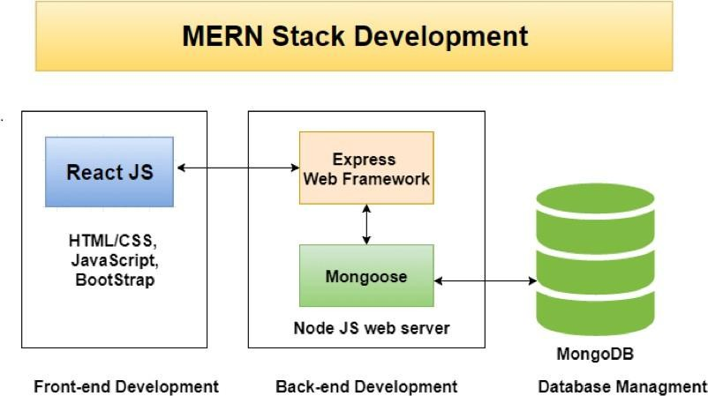.

### Fig 4.1 – MERN Stack Overview

## Frontend Design

The frontend of **CampHire** was developed using **React.js**, which enables the creation of reusable, modular components and provides a dynamic, single-page application experience. To ensure a modern and responsive design, **Tailwind CSS** and **Chakra UI** were used, offering utility-first styling and a consistent design system.

### Core UI Components

#### **Home Page**

* Serves as the landing page with a clean introduction to CampHire.
* Features quick navigation to login/register and showcases platform highlights like student-employer matchmaking, real-time assessments, and job tracking.

#### **Dashboard Pages**

* **Student Dashboard**: Displays job listings, application status, Neo assessment results, and profile completion meter.
* **Recruiter Dashboard**: Allows recruiters to post jobs, view applicants, and manage interviews and application pipelines.

#### **Job Listing Page**

* Shows a searchable and filterable list of active job posts.
* Each job card includes title, company info, location, type (internship/full-time), and an “Apply Now” button.

#### **Job Application Page**

* A dedicated page for students to view job details and apply with their saved resumes.
* Shows application history and submission status.

#### **Login/Register Page**

* Form-based authentication with input validation, feedback messages, and role-based login options (student/recruiter).
* JWT tokens are handled on the frontend for session management.

## Backend Implementation

The backend of **CampHire** is built using **Node.js** and **Express.js**, following a modular architecture that separates concerns across routes, controllers, services, and middleware. This design ensures scalability, ease of maintenance, and high performance across different features of the platform.

### Key Features :-

#### **REST API Endpoints**

* APIs are designed to handle essential operations like:
  + **User Registration and Login** (Students and Recruiters)
  + **Job Posting** and **Job Listing Retrieval**
  + **Job Applications** and **Application Status Updates**
  + **Neo Platform Assessment Integration**
  + **Resume Uploads and Retrieval**
  + **Email Notifications** for applied jobs or recruiter alerts

#### **Authentication & Authorization**

* **JWT-based authentication** is implemented to secure endpoints and manage sessions.
* Role-based access control is enforced to differentiate between student and recruiter functionalities.
* Middleware checks ensure only authorized users can post jobs, apply, or access certain dashboards.

#### **Middleware Integration**

* **Authentication Middleware**: Validates JWT tokens and attaches user data to requests.
* **Error Handling Middleware**: Captures and formats server-side errors for a smooth client experience.
* **CORS Configuration**: Ensures secure cross-origin requests between frontend and backend during development and production.

#### **Database Integration**

* Uses **MongoDB Atlas** for storing:
  + User profiles and roles
  + Job posts and their metadata
  + Student applications and assessment results
* **Mongoose** is used as the ODM to manage schemas and queries efficiently.

#### **Real-Time Features (Planned)**

* The backend is designed to support **future integration of real-time assessments** and chat using **Socket.IO**, where employers can conduct live coding or Q&A sessions.

### Performance and Concurrency

* Asynchronous, non-blocking operations ensure that multiple users (students and recruiters) can interact with the system simultaneously without delay.
* Proper indexing and pagination are used to handle large datasets like job listings and applications efficiently.

## Database Design

The database for CampHire is designed to handle

* + 1. **User Schema**

The User schema stores information about registered users, including their credentials, phone number, role, and metadata.

|  |  |  |  |
| --- | --- | --- | --- |
| Field | Type | Description | Constraints |
| _id | String | Unique identifier for each user. | Primary Key, Auto- Generated |
| fullname | String | The name chosen by the user for display. | Unique, Required |
| email | String | The email address of  the user. | Unique, Required |
| password | String | Hashed password for secure authentication. | Required |
| createdAt | Date | The date and time when the user  account was created. | Auto-Generated |
| updatedAt | Date | The last time the user updated the data | Auto-Updated |
| phoneNumber | Number | The phone number of the user | Required, Unique |
| role | String | The role of the user, eg: Student or Recruiter | Required |
| bio | String | The bio or description of the user |  |
| skills | String | The skills that the user has |  |
| resume | String | The resume of the user |  |
| resumeOriginalName | String | The original Name of the resume |  |
| profilePhoto | String | The user’s profile photo |  |

### Table 4.4.1 User Schema

* + 1. **Job Schema**

|  |  |  |  |
| --- | --- | --- | --- |
| Field | Type | Description | Constraints |
| _id | String | Unique identifier for each job posting. | Primary Key, Auto- Generated |
| title | String | This is the title of the job | Required |
| description | String | The description of the job | Required |
| requirements | String | The requirements list |  |
| salary | Number | The salary that the job posting is offering | Required |
| experienceLevel | Number | The amount of experience that is required for the job | Required |
| location | String | The location of the job posting | Required |
| jobType | String | The type of the job, eg, permanent, remote, hybrid | Required |
| position | Number | The number of positions available for the job | Required |
| company | Object ID | The company details which posted the job | Required |
| Created_by | Object ID | The person who created the job posting | Required |
| applications | ObjectID | The array of applications applied for this job |  |
| CreatedAt | Date | The time at which this job is created | Auto-Generated, Required |

### Table 4.4.2 Job Schema

* + 1. **Company Schema**

|  |  |  |  |
| --- | --- | --- | --- |
| Field | Type | Description | Constraints |
| _id | String | Unique Identification for the company | Primary Key, Auto- Generated |
| name | String | A name given to the room for easy identification. | Required, Unique |
| description | String | The description of the company | Required |
| website | String | The website url of the company |  |
| logo | String | The logo URL of the company |  |
| createdAt | Date | The time at which the comapny is created | Auto-Generated, Required |
| updatedAt | Date | The time at which the company details are updated | Auto-Generated, Required |

### Table 4.4.3 Company Schema

* + 1. **Application Schema**

|  |  |  |  |
| --- | --- | --- | --- |
| Field | Type | Description | Constraints |
| _id | String | Unique Identification for the application | Primary Key, Auto- Generated, Required |
| job | Object ID | The job reference of the application | Required |
| applicant | Object ID | The applicant details of the application | Required |
| status | String | The status of the application i.e pending, accepted, rejected | Default: Pending |
| createdAt | Date | The time at which the application was created | Required, Auto-Generated |
| updatedAt | Dare | The time at which the application was updated | Required, Auto Generated |

### Table 4.4.4 Application Schema

## Modules

### 1. Authentication & Access Control Module

* Handles registration and login for **Students** and **Employers**.
* Implements **role-based access control**, where students can apply for jobs and employers can post job listings.
* Secures user sessions using **JWT (JSON Web Tokens)** and encrypts passwords with **bcrypt**.

### 2. Job Posting and Application Module

* Enables employers to **create**, **edit**, and **manage** job listings.
* Allows students to **view job openings** and **apply** directly through the platform.
* Tracks the application status (Applied, Shortlisted, Rejected, etc.) and updates students accordingly.

### 3. Assessment Redirection Module

* After applying for a job, students are redirected to an **external Neo Platform** for taking assessments.
* Stores assessment links and application updates in the system without hosting or conducting the assessments directly.

### 4. Profile Management Module

* Students can create and manage **basic profiles** with personal details, academic records, and skill sets (without portfolio uploads).
* Employers can view student profiles and make informed hiring decisions.

### 5. Notification & Email Module

* Sends automatic **email notifications** for:
  + Successful job application submissions
  + Changes in application status
  + New applicant alerts to employers
* Maintains communication between platform and users through reliable transactional emails.

### 6. Job Status and Selection Module

* Employers can view lists of applicants for their jobs and **update application statuses**.
* Students receive updates about whether they have been shortlisted, rejected, or selected.

### 7. User Interface Module

* Built using **React.js** for dynamic and responsive front-end design.
* Ensures mobile-first responsiveness, clean navigation, and intuitive user experiences across devices.

### 8. Security Module

* Secures all API routes with **JWT Authentication**.
* Encrypts sensitive user data using **bcrypt hashing**.
* Applies **input validation** and **CORS policies** to prevent common security vulnerabilities like XSS and CSRF attacks.

### 9. Admin & Moderation Module

* Basic admin functionalities to monitor jobs and applications, ensuring the platform remains clean and abuse-free.
* Admin can download reports for applications, jobs, companies and users.
* Can be expanded for role upgrades, user banning, or platform announcements.

.

**CHAPTER 5**

**TESTING AND EVALUATION**

## Introduction

Testing is an integral part of the software development lifecycle and plays a crucial role in ensuring the reliability, performance, and functionality of an application. For the **CampHire** project, which emphasizes job applications, employer-student interactions, secure authentication, and external assessment redirection, rigorous testing is paramount to ensure seamless operation under various user flows and load conditions.

The testing phase focuses on identifying and fixing defects, verifying that all system functionalities align with the specified requirements, and ensuring an exceptional and secure user experience for both students and employers.

This chapter delves into the comprehensive testing strategy employed for the **CampHire** platform. It outlines the types of testing conducted, including **unit testing** for individual functions (like login, job posting, and applying for jobs), **integration testing** for interactions between modules (such as applying for a job and triggering email notifications), and **system testing** to validate the entire application as a unified solution. Additionally, a detailed **test plan** defines the scope, objectives, and methodologies followed to systematically detect and fix issues.

A key aspect of the **CampHire** project is its ability to efficiently manage user authentication, job workflows, and real-time updates regarding application status. Therefore, the testing phase also includes **load testing** to assess system performance under multiple simultaneous applications, **security testing** to validate the strength of JWT tokens, password encryption, and data protection, and **usability testing** to ensure intuitive navigation for all user types.

By following a structured and methodical testing approach, the **CampHire** project aims to deliver a high-quality, user-friendly, and scalable application that meets the expectations of students, recruiters, and college administrators. This chapter also presents **test cases**, **evaluation results**, and **conclusions** based on the testing outcomes, highlighting the platform’s readiness for real-world deployment.

## Types of Testing :-

* + - **Unit Testing**

Unit testing focuses on validating individual components of the **CampHire** application, such as functions, modules, and classes. Each unit was tested independently to ensure its correctness and behavior under different conditions. Key areas tested include user authentication, job posting functionality, job application submissions, email notification triggers, and secure session management.

* + - **Integration Testing**

Integration testing was performed to evaluate the interaction between various modules in the system. For example, tests were conducted to verify the smooth functioning between the frontend (React.js), backend APIs (Node.js/Express.js), and database (MongoDB) during operations like user registration, login, job posting, and application tracking. Special focus was given to verifying the integration of external systems like the **Neo Platform** for assessments and ensuring email notifications were triggered correctly.

* + - **System Testing**

System testing ensured that the complete **CampHire** application worked as a cohesive and reliable platform. This included end-to-end testing of core features such as user registration, login, job search, job application, employer dashboard access, and application status updates. Emphasis was placed on the overall usability, security, and responsiveness of the system to deliver a seamless experience for both students and employers.

## Test Plan:

The test plan outlines the objectives, scope, resources, and schedule for the testing process.

### Objectives:

* Validate the core functionalities of the **CampHire** platform, including user authentication, job posting, job application, and email notifications.
* Ensure seamless integration with the external **Neo Platform** for assessment handling.
* Verify the correct working of role-based dashboards for students and employers.

### Scope:

* End-to-end testing of all modules including Authentication, Job Management, Application Management, Email Notification System, and Neo Platform integration.
* Testing of security measures like JWT authentication, input validation, and session management.
* Usability testing to ensure a smooth and intuitive user experience across devices.

### Resources:

* **Postman** for API endpoint validation and backend functionality testing.
* **MongoDB Compass** for database verification.
* **Browsers** (Chrome, Firefox, Edge) for cross-browser UI testing.
* **Jest** and **React Testing Library** for frontend unit and integration testing.

### Schedule:

* Testing was conducted during the final phase of development.
* Unit testing was done continuously alongside module development.
* Integration and system testing were scheduled after all modules were integrated.
* Bug fixes and final validation were completed before deployment.

## Test Cases

A Test Case is a collection of situations or variables that a tester will use to verify whether a system meets requirements or operates appropriately. Below are some test cases which were generated during the system testing

|  |  |  |  |
| --- | --- | --- | --- |
| **Test Case ID** | **Description** | **Expected Result** | **Actual Result** |
| **TC001** | Student logs in with valid credentials | Login successful | Login successful |
| **TC002** | Employer logs in with invalid credentials | Error message displayed | Error message displayed |
| **TC003** | Employer creates a new job posting | Job posted successfully | Job posted successfully |
| **TC004** | Student applies for a job | Application submitted successfully | Application submitted successfully |
| **TC005** | System sends email notification after application submission | Email received by employer | Email received by employer |
| **TC006** | Student tries to upload portfolio (feature not supported) | Upload option not available | Upload option not available |
| **TC007** | Student attempts to take an assessment through Neo Platform | Redirects to Neo Platform successfully | Redirects to Neo Platform successfully |
| **TC008** | Employer views list of applicants for a job posting | Applicants list displayed correctly | Applicants list displayed correctly |

### Table 5.4 Test Cases

### Test Case Description

|  |  |  |  |
| --- | --- | --- | --- |
| **No.** | **Test Case** | **Actual Output** | **Status** |
| 1 | Login Success | Loading the main page. | Ok |
| 2 | Login Fail | Displaying a message “Invalid credentials.” | Ok |

### Table 5.5 Test Case Description

* 1. **Results of the Evaluation**

The evaluation results indicate that the application meets all functional and non-functional requirements. Key outcomes include:

* **Authentication and Access Control:**  
   Students and employers were able to register, log in, and manage access securely with JWT authentication.
* **Job Posting and Application:**  
   Employers were able to create job listings smoothly, and students could apply without any errors. Application statuses updated correctly, and notifications were triggered as expected.
* **Email Notifications:**  
   Both employers and students received accurate and timely email updates regarding job applications and status changes.
* **Real-Time Collaboration for Job Listings:**  
   While CampHire does not involve real-time assessments internally, the system successfully redirects students to the external Neo Platform for assessments without errors.
* **Data Storage and Retrieval:**  
   Job postings, student applications, and user data were consistently saved and retrieved from MongoDB without loss or corruption.
* **Performance:**  
   The system handled concurrent activities (such as multiple students applying to jobs at once) effectively without noticeable delays or system crashes.
* **Security:**  
   Sensitive data, including passwords, were protected with encryption techniques like bcrypt hashing, and proper CORS policies were enforced across the application.
* **User Interface and Experience:**  
   The React-based UI was responsive, intuitive, and consistent across different devices and screen sizes, ensuring a smooth user journey.

## 5.6 Conclusion of testing results

The testing phase of the CampHire project confirmed that the platform effectively delivers on its intended functionality across a variety of real-world scenarios. Core features such as job posting, student application submission, and real-time email notifications performed reliably during unit and system testing. The registration and login systems, supported by JWT authentication, maintained data integrity and user role access control as expected. Integration testing showed smooth communication between frontend components, backend APIs, and the MongoDB database.

Stress testing was performed to ensure the platform could handle multiple employers and students interacting simultaneously without lags or crashes. The job application flow—from listing to email notification—was validated thoroughly, confirming that status changes were promptly communicated. Usability testing with end users revealed that the interface was intuitive and responsive, though minor enhancements were made to improve the visibility of job details and profile completion steps.

Additionally, feedback from student users highlighted the need for improved filtering and keyword-based job matching, which will be considered for future iterations. While the overall performance met expectations, additional optimization will help support a larger user base and faster response times.

In conclusion, CampHire has successfully passed all critical testing phases, demonstrating its readiness for deployment in academic and organizational environments. With robust functionality and a user-focused design, it stands as a reliable and scalable platform for campus recruitment.

**5.7 Summary**

The CampHire project, a full-stack job portal tailored for campus placements, underwent a comprehensive testing process to validate its functionality, performance, and user experience across multiple use cases. The testing strategy was divided into distinct phases: unit testing, integration testing, system testing, and user acceptance testing, each targeting specific components and workflows of the application to ensure its reliability in real-world academic and recruitment settings.

Key features of CampHire, including employer registration, job postings, student applications, email notifications, and secure authentication using JWT, were thoroughly tested. Unit testing focused on validating backend APIs, database operations, and frontend components such as the job listing interface and user dashboards. Integration testing ensured seamless interaction between the frontend, backend, and MongoDB database, verifying that job application data and profile information were consistently handled throughout the system.

System testing evaluated the platform as a whole, including performance under concurrent usage by employers and students. Stress testing was conducted to simulate multiple job postings and applications in real-time, confirming that the platform could scale effectively.

Usability testing involved feedback from both student and recruiter personas, helping refine the UI layout and improve clarity in workflows such as job filtering and status updates. Compatibility testing was performed across various browsers (Chrome, Edge, Firefox) and devices, ensuring a uniform and responsive user experience.

**CHAPTER 6**

**RESULT AND DISCUSSION**

* 1. **Output Screenshots**

**5.1.1 Home Page**

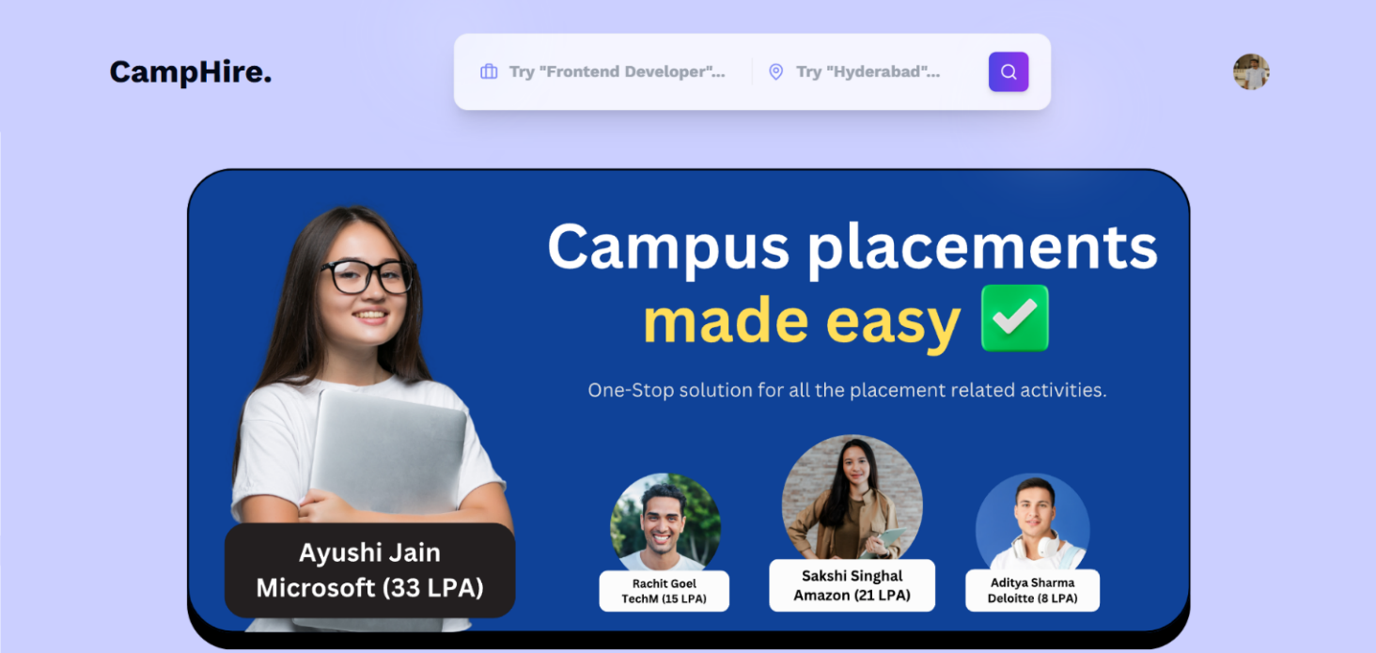

const Home = () => {

  useGetAllJobs();

  const { user } = useSelector(store => store.auth);

  const navigate = useNavigate();

  useEffect(() => {

    if (user?.role === 'recruiter') {

      navigate("/admin/companies");

    }

  }, []);

  return (

    <div>

      <Navbar />

      <HeroSection />

      {/* <CategoryCarousel /> */}

      { !user && <HomePageSteps />}

      <LatestJobs />

      <Footer />

    </div>

  )

}

This code snippet explains how the home page is created.

**5.1.2 Home Page (Continued)**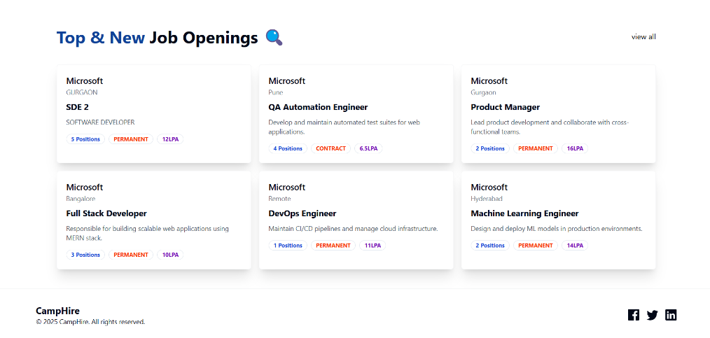

The following is the code snippet for the top and new job openings section:

import React from 'react'

import { Badge } from './ui/badge'

import { useNavigate } from 'react-router-dom'

const LatestJobCards = ({job}) => {

    const navigate = useNavigate();

    return (

        <div onClick={()=> navigate(`/description/${job._id}`)} className='p-5 rounded-md shadow-xl bg-white border border-gray-100 cursor-pointer'>

            <div>

                <h1 className='font-medium text-lg'>{job?.company?.name}</h1>

                <p className='text-sm text-gray-500'>{job?.location}</p>

            </div>

            <div>

                <h1 className='font-bold text-lg my-2'>{job?.title}</h1>

                <p className='text-sm text-gray-600'>{job?.description}</p>

            </div>

            <div className='flex items-center gap-2 mt-4'>

                <Badge className={'text-blue-700 font-bold'} variant="ghost">{job?.position} Positions</Badge>

                <Badge className={'text-[#F83002] font-bold'} variant="ghost">{job?.jobType}</Badge>

                <Badge className={'text-[#7209b7] font-bold'} variant="ghost">{job?.salary}LPA</Badge>

            </div>

        </div>

    )

}

export default LatestJobCards

**5.1.3 Profile Menu**

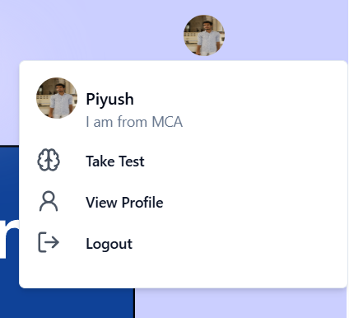

The profile menu code:

 <div>

          {!user ? (

            <div className="flex items-center gap-2">

              <Link to="/login">

                <Button className="rounded-xl text-[16px] py-2 font-semibold font-canvaSans px-6">

                  Login

                </Button>

              </Link>

              <Link to="/signup">

                <Button className="rounded-xl text-[16px] py-2 font-semibold font-canvaSans px-6 bg-white border-2 border-black text-black hover:text-white hover:bg-black">

                  Signup

                </Button>

              </Link>

            </div>

          ) : (

            <Popover>

              <PopoverTrigger asChild>

                <Avatar className="cursor-pointer">

                  <AvatarImage

                    src={user?.profile?.profilePhoto}

                    alt="@shadcn"

                  />

                </Avatar>

              </PopoverTrigger>

              <PopoverContent className="w-80">

                <div className="">

                  <div className="flex gap-2 space-y-2">

                    <Avatar className="cursor-pointer">

                      <AvatarImage

                        src={user?.profile?.profilePhoto}

                        alt="@shadcn"

                      />

                    </Avatar>

                    <div>

                      <h4 className="font-medium">{user?.fullname}</h4>

                      <p className="text-sm text-muted-foreground">

                        {user?.profile?.bio}

                      </p>

                    </div>

                  </div>

                  <div className="flex flex-col my-2 text-gray-600">

                    <div className="flex w-fit items-center gap-2 cursor-pointer">

                      <Brain />

                      <Button variant="link">

                        {" "}

                        <Link

                          to="https://kiet698.examly.io/login"

                          target="_blank"

                        >

                          Take Test

                        </Link>

                      </Button>

                    </div>

                    <div className="flex w-fit items-center gap-2 cursor-pointer">

                      <User2 />

                      <Button variant="link">

                        {" "}

                        <Link to="/profile">View Profile</Link>

                      </Button>

                    </div>

                    <div className="flex w-fit items-center gap-2 cursor-pointer">

                      <LogOut />

                      <Button onClick={logoutHandler} variant="link">

                        Logout

                      </Button>

                    </div>

                  </div>

                </div>

              </PopoverContent>

            </Popover>

          )}

        </div>

      </div>

    </div>

**5.1.4 Profile Section**

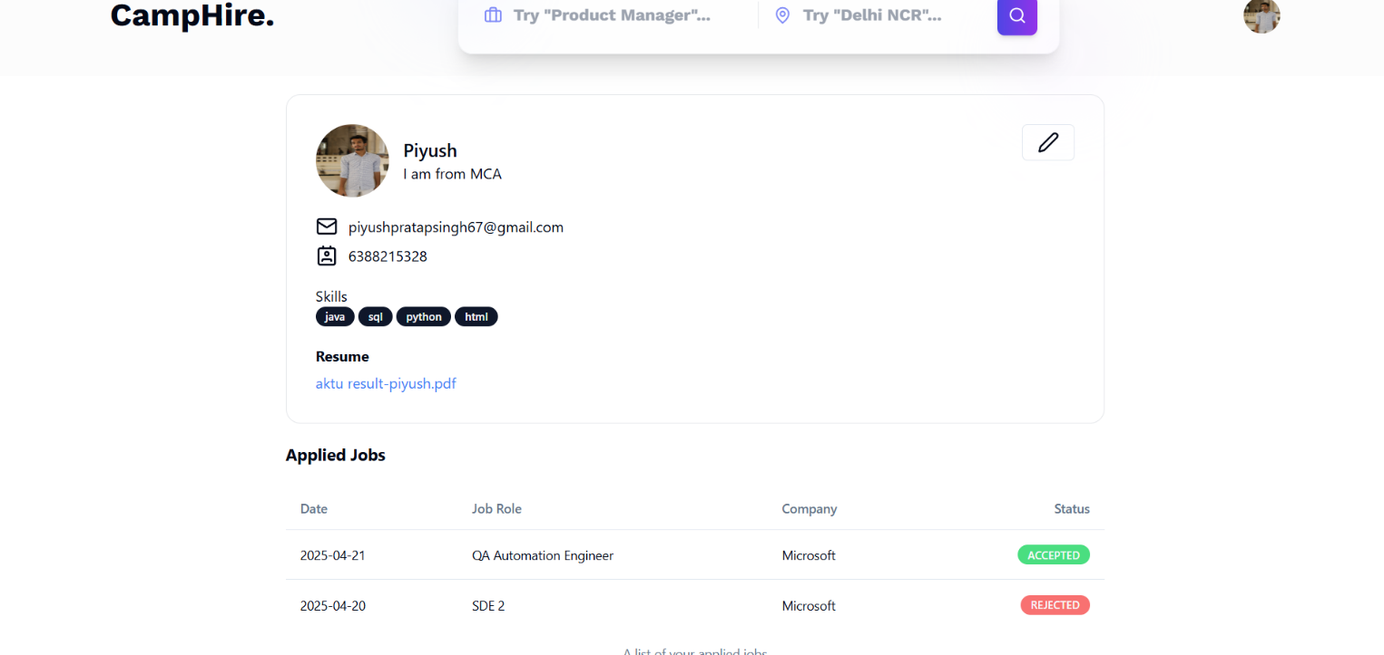

const Profile = () => {

  useGetAppliedJobs();

  const [open, setOpen] = useState(false);

  const { user } = useSelector((store) => store.auth);

  return (

    <div>

      <Navbar />

      <div className="max-w-4xl mx-auto bg-white border border-gray-200 rounded-2xl my-5 p-8">

        <div className="flex justify-between">

          <div className="flex items-center gap-4">

            <Avatar className="h-20 w-20">

              <AvatarImage src={user?.profile?.profilePhoto} alt="profile" />

            </Avatar>

            <div>

              <h1 className="font-medium text-xl">{user?.fullname}</h1>

              <p>{user?.profile?.bio}</p>

            </div>

          </div>

          <Button

            onClick={() => setOpen(true)}

            className="text-right"

            variant="outline"

          >

            <Pen />

          </Button>

        </div>

        <div className="my-5">

          <div className="flex items-center gap-3 my-2">

            <Mail />

            <span>{user?.email}</span>

          </div>

          <div className="flex items-center gap-3 my-2">

            <Contact />

            <span>{user?.phoneNumber}</span>

          </div>

        </div>

        <div className="my-5">

          <h1>Skills</h1>

          <div className="flex items-center gap-1">

            {user?.profile?.skills.length !== 0 ? (

              user?.profile?.skills.map((item, index) => (

                <Badge key={index}>{item}</Badge>

              ))

            ) : (

              <span>NA</span>

            )}

          </div>

        </div>

        <div className="grid w-full max-w-sm items-center gap-1.5">

          <Label className="text-md font-bold">Resume</Label>

          {isResume ? (

            <a

              target="blank"

              href={user?.profile?.resume}

              className="text-blue-500 w-full hover:underline cursor-pointer"

            >

              {user?.profile?.resumeOriginalName}

            </a>

          ) : (

            <span>NA</span>

          )}

        </div>

      </div>

      <div className="max-w-4xl mx-auto bg-white rounded-2xl">

        <h1 className="font-bold text-lg my-5">Applied Jobs</h1>

        {/* Applied Job Table   */}

        <AppliedJobTable />

      </div>

      <UpdateProfileDialog open={open} setOpen={setOpen} />

    </div>

  );

};

export default Profile;

**5.1.5 Job Posting Module**

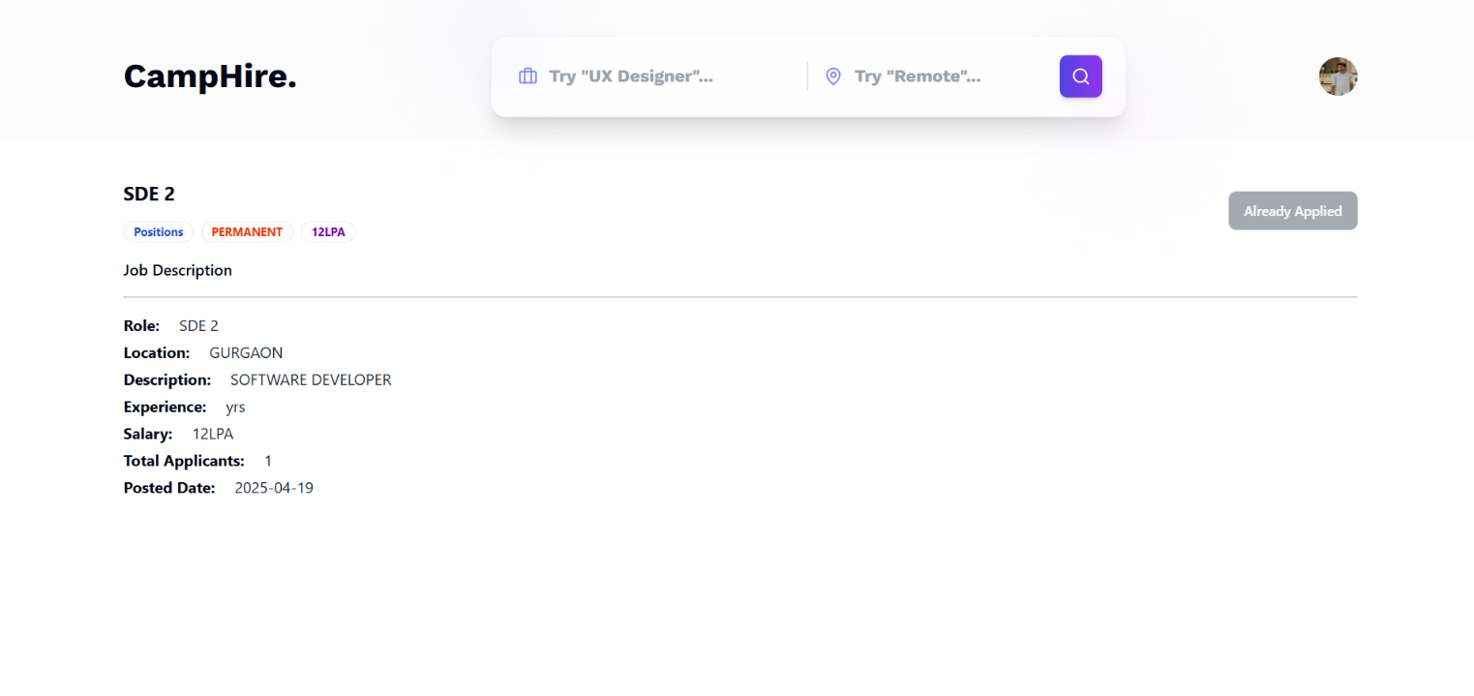

 <div className="p-5 rounded-md shadow-xl bg-white border border-gray-100">

      <div className="flex items-center justify-between">

        <p className="text-sm text-gray-500">

          {daysAgoFunction(job?.createdAt) === 0

            ? "Today"

            : `${daysAgoFunction(job?.createdAt)} days ago`}

        </p>

        <Button variant="outline" className="rounded-full" size="icon">

          <Share2 onClick={() => {

            navigator.clipboard.writeText(`localhost:5173/description/${job?._id}`);

            toast.success("Link copied to clipboard!");

          }}/>

        </Button>

      </div>

      <div className="flex items-center gap-2 my-2">

        <Button className="p-6" variant="outline" size="icon">

          <Avatar>

            <AvatarImage src={job?.company?.logo} />

          </Avatar>

        </Button>

        <div>

          <h1 className="font-medium text-lg">{job?.company?.name}</h1>

          <p className="text-sm text-gray-500">{job?.location}</p>

        </div>

      </div>

      <div>

        <h1 className="font-bold text-lg my-2">{job?.title}</h1>

        <p className="text-sm text-gray-600">{job?.description}</p>

      </div>

      <div className="flex items-center gap-2 mt-4">

        <Badge className={"text-blue-700 font-bold"} variant="ghost">

          {job?.position} Positions

        </Badge>

        <Badge className={"text-[#F83002] font-bold"} variant="ghost">

          {job?.jobType}

        </Badge>

        <Badge className={"text-[#7209b7] font-bold"} variant="ghost">

          {job?.salary}LPA

        </Badge>

      </div>

      <div className="flex items-center gap-4 mt-4">

        <Button

          onClick={() => navigate(`/description/${job?._id}`)}

          variant="outline"

          className="bg-[#7209b7] text-white hover:bg-[#5f32ad] hover:text-white"

        >

          View Full Details

        </Button>

      </div>

    </div>

  );

};

**5.1.6 All Jobs**

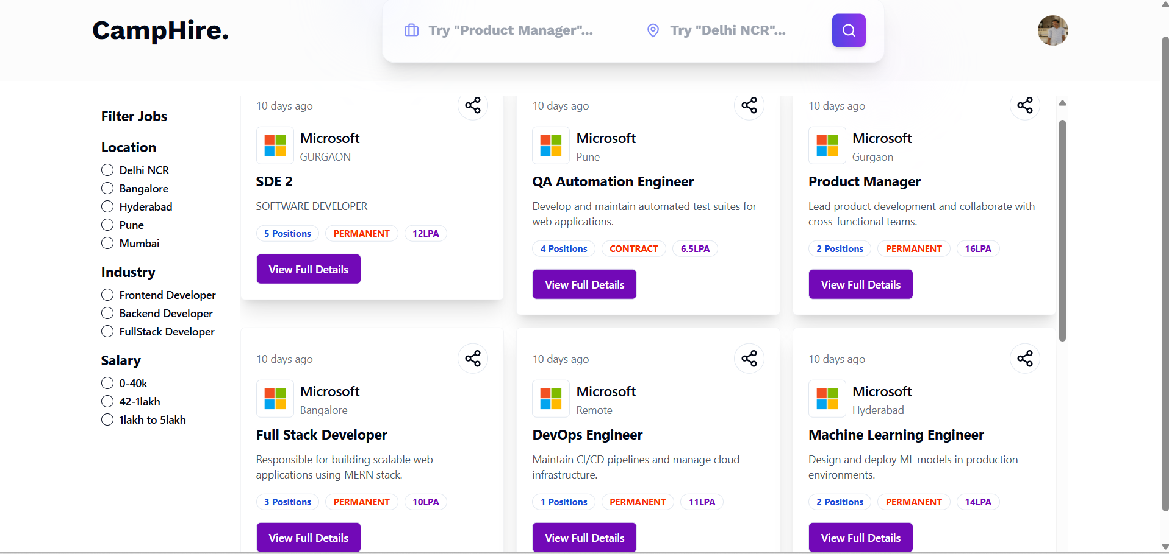

const Jobs = () => {

    const { allJobs, searchedQuery } = useSelector(store => store.job);

    const [filterJobs, setFilterJobs] = useState(allJobs);

    useEffect(() => {

        if (searchedQuery) {

            const filteredJobs = allJobs.filter((job) => {

                return job.title.toLowerCase().includes(searchedQuery.toLowerCase()) ||

                    job.description.toLowerCase().includes(searchedQuery.toLowerCase()) ||

                    job.location.toLowerCase().includes(searchedQuery.toLowerCase())

            })

            setFilterJobs(filteredJobs)

        } else {

            setFilterJobs(allJobs)

        }

    }, [allJobs, searchedQuery]);

    return (

        <div>

            <Navbar />

            <div className='max-w-7xl mx-auto mt-5'>

                <div className='flex gap-5'>

                    <div className='w-20%'>

                        <FilterCard />

                    </div>

                    {

                        filterJobs.length <= 0 ? <span>Job not found</span> : (

                            <div className='flex-1 h-[88vh] overflow-y-auto pb-5'>

                                <div className='grid grid-cols-3 gap-4'>

                                    {

                                        filterJobs.map((job) => (

                                            <motion.div

                                                initial={{ opacity: 0, x: 100 }}

                                                animate={{ opacity: 1, x: 0 }}

                                                exit={{ opacity: 0, x: -100 }}

                                                transition={{ duration: 0.3 }}

                                                key={job?._id}>

                                                <Job job={job} />

                                            </motion.div>

                                        ))

                                    }

                                </div>

                            </div>

                        )

                    }

                </div>

            </div>

        </div>

    )

}

**5.1.7 Search Page**

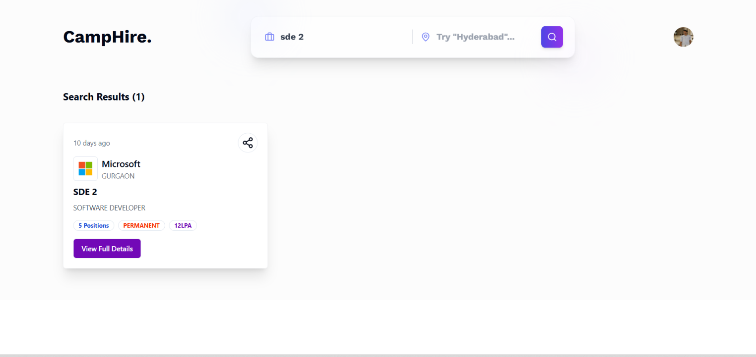

const Browse = () => {

  const location = useLocation();

  // const searchQuery = location.state;

  const searchQuery = location.state?.jobTitle || "";

  const locationQuery = location.state?.location || "";

  useGetAllJobs();

  const { allJobs } = useSelector((store) => store.job);

  const dispatch = useDispatch();

  useEffect(() => {

    return () => {

      dispatch(setSearchedQuery(""));

    };

  }, []);

  const [filteredJobs, setFilteredJobs] = React.useState(allJobs);

  useEffect(() => {

    setFilteredJobs(

      allJobs.filter((job) => {

        return (

          job.title.toLowerCase().includes(searchQuery.toLowerCase()) ||

          job.description.toLowerCase().includes(searchQuery.toLowerCase()) ||

          job.location.toLowerCase().includes(searchQuery.toLowerCase())

        );

      })

    );

  }, [searchQuery]);

  return (

    <div className="bg-[#fcfcfc] pb-6">

      <Navbar />

      <div className="max-w-7xl mx-auto my-10">

        <h1 className="font-bold text-xl my-10">

          Search Results ({filteredJobs.length})

        </h1>

        <div className="grid grid-cols-3 gap-4">

          {filteredJobs.map((job) => {

            return <Job key={job._id} job={job} />;

          })}

        </div>

      </div>

    </div>

  );

};

export default Browse;

**5.1.8 Login Page**



**5.1.9 Signup Page**

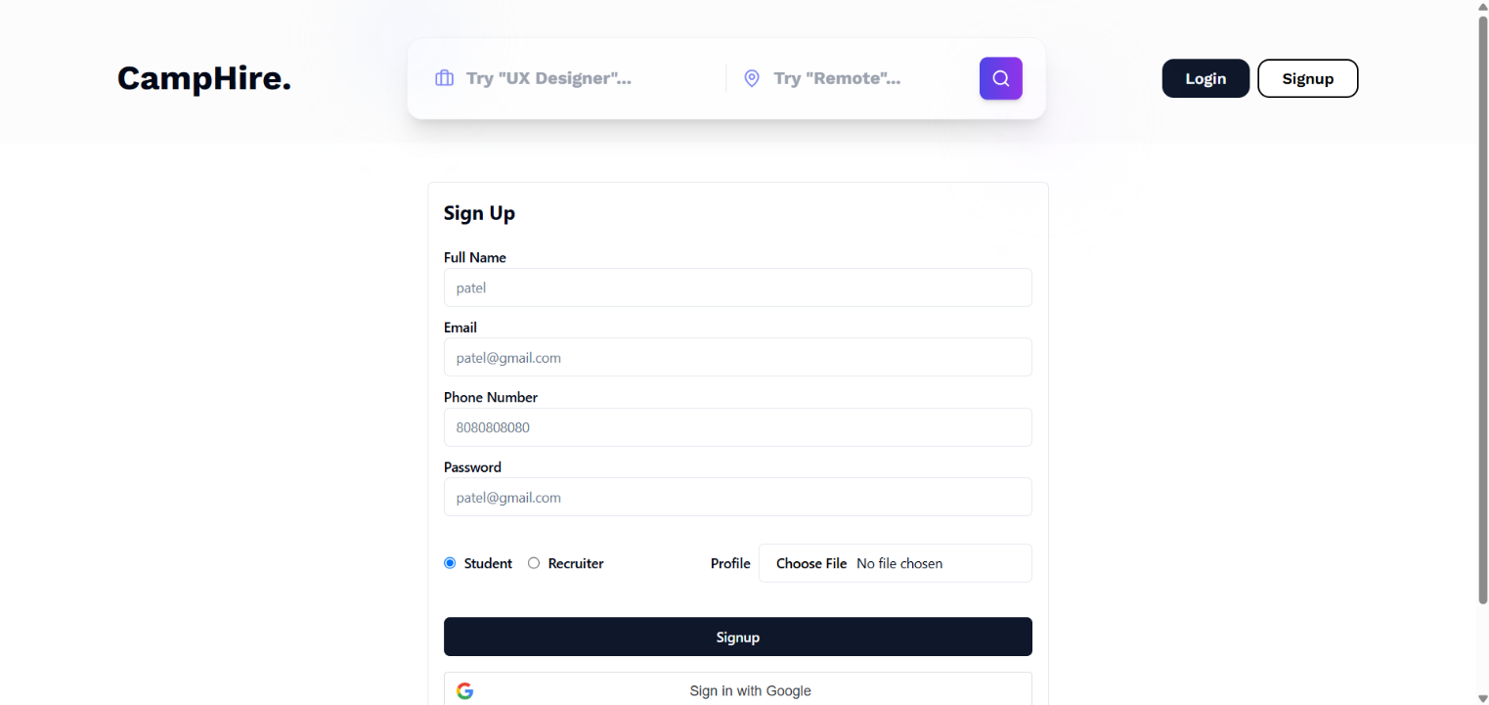

**5.1.10 Admin Page**

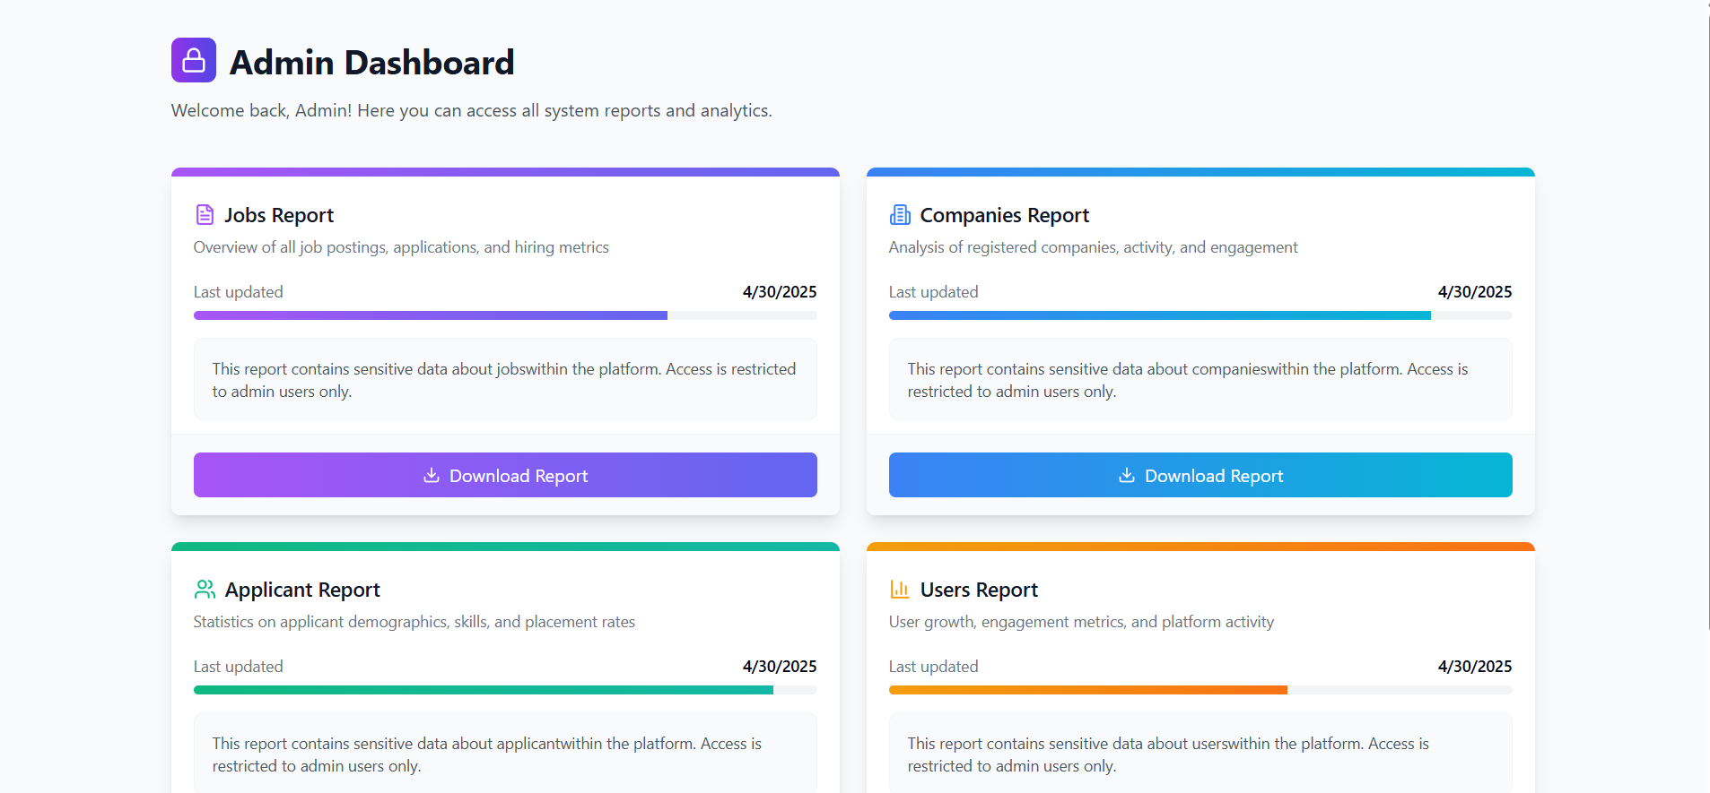

  const reports = [

    {

      title: "Jobs Report",

      description:

        "Overview of all job postings, applications, and hiring metrics",

      icon: <FileText className="h-5 w-5 text-purple-500" />,

      color: "from-purple-500 to-indigo-500",

      backendLink: "http://localhost:8000/api/v1/job/get",

    },

    {

      title: "Companies Report",

      description: "Analysis of registered companies, activity, and engagement",

      icon: <Building2 className="h-5 w-5 text-blue-500" />,

      color: "from-blue-500 to-cyan-500",

      backendLink: "http://localhost:8000/api/v1/company/getAll",

    },

    {

      title: "Applicant Report",

      description:

        "Statistics on applicant demographics, skills, and placement rates",

      icon: <Users className="h-5 w-5 text-emerald-500" />,

      color: "from-emerald-500 to-teal-500",

      backendLink: "http://localhost:8000/api/v1/application/getAll",

    },

    {

      title: "Users Report",

      description: "User growth, engagement metrics, and platform activity",

      icon: <BarChart3 className="h-5 w-5 text-amber-500" />,

      color: "from-amber-500 to-orange-500",

      backendLink: "http://localhost:8000/api/v1/user/getAll",

    },

  ];

  return (

    <div className="min-h-screen bg-gray-50">

      <div className="max-w-7xl mx-auto px-4 sm:px-6 lg:px-8 py-10">

        {/* Header */}

        <div className="mb-10">

          <div className="flex items-center space-x-3">

            <div className="bg-gradient-to-r from-purple-600 to-indigo-600 p-2 rounded-lg">

              <Lock className="h-6 w-6 text-white" />

            </div>

            <h1 className="text-3xl font-bold text-gray-900">

              Admin Dashboard

            </h1>

          </div>

          <p className="mt-3 text-gray-600 max-w-3xl">

            Welcome back, Admin! Here you can access all system reports and

            analytics.

          </p>

        </div>

        {/* Reports Grid */}

        <div className="grid grid-cols-1 md:grid-cols-2 gap-6 mb-8">

          {reports.map((report, index) => (

            <div

              key={index}

              className="bg-white rounded-lg overflow-hidden border-0 shadow-lg hover:shadow-xl transition-shadow duration-300"

            >

              <div className={`h-2 bg-gradient-to-r ${report.color}`} />

              <div className="p-5 pb-2">

                <div className="flex items-center space-x-2">

                  {report.icon}

                  <h3 className="text-lg font-medium text-gray-900">

                    {report.title}

                  </h3>

                </div>

                <p className="text-sm text-gray-500 mt-1">

                  {report.description}

                </p>

              </div>

              <div className="px-5 py-3">

                <div className="space-y-2">

                  <div className="flex justify-between items-center text-sm">

                    <span className="text-gray-500">Last updated</span>

                    <span className="font-medium">

                      {new Date().toLocaleDateString()}

                    </span>

                  </div>

                  <div className="h-2 bg-gray-100 rounded-full overflow-hidden">

                    <div

                      className={`h-full bg-gradient-to-r ${report.color}`}

                      style={{

                        width: `${Math.floor(Math.random() * 40) + 60}%`,

                      }}

                    />

                  </div>

                </div>

                <div className="mt-4 p-4 bg-gray-50 rounded-lg border border-gray-100">

                  <p className="text-gray-600 text-sm">

                    This report contains sensitive data about{" "}

                    {report.title.toLowerCase().replace(" report", "")}

                    within the platform. Access is restricted to admin users

                    only.

                  </p>

                </div>

              </div>

              <div className="px-5 py-4 bg-gray-50 border-t border-gray-100">

                <button

                  className={`w-full inline-flex items-center justify-center px-4 py-2 rounded-md text-white bg-gradient-to-r ${report.color} hover:opacity-90 transition-opacity`}

                  onClick={() =>

                    handleDownload(

                      report.title.replace(" Report", ""),

                      report.backendLink

                    )

                  }

                >

                  <Download className="mr-2 h-4 w-4" />

                  Download Report

                </button>

              </div>

            </div>

          ))}

        </div>

        {/* Action Buttons */}

        <div className="flex justify-center mt-8">

          <button className="inline-flex items-center justify-center px-4 py-2 rounded-md text-purple-700 bg-white border border-purple-200 hover:bg-purple-50 transition-colors mr-4">

            <Home className="mr-2 h-4 w-4" />

            <a href="/">Return to Home</a>

          </button>

        </div>

      </div>

    </div>

  );

};

export default AdminDashboard;

**5.1.11 Company Page**

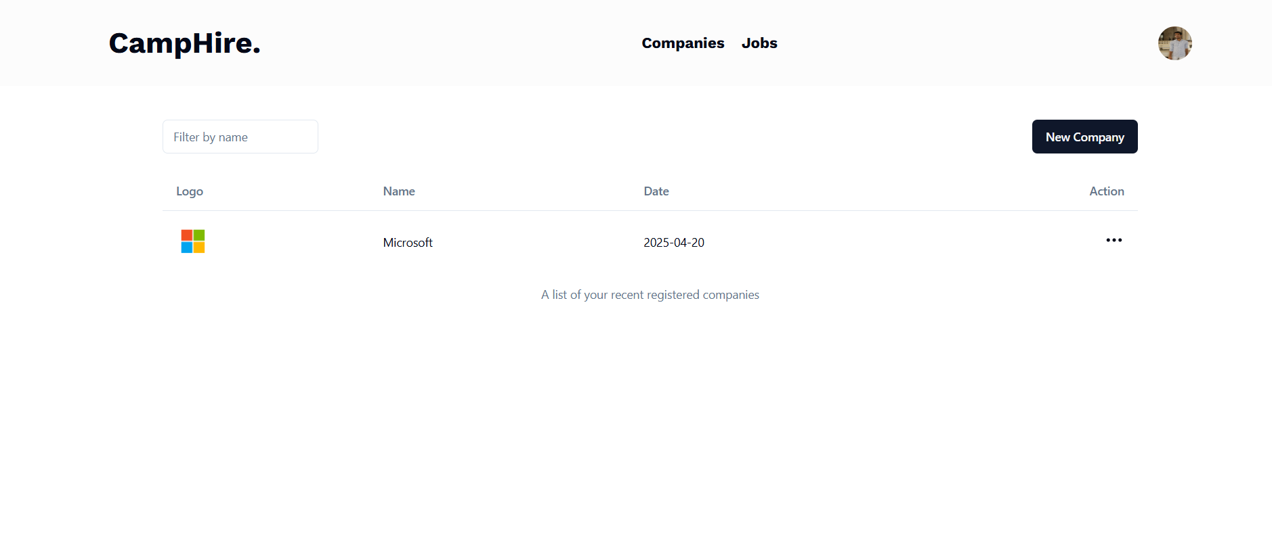

* + 1. **Job Page**

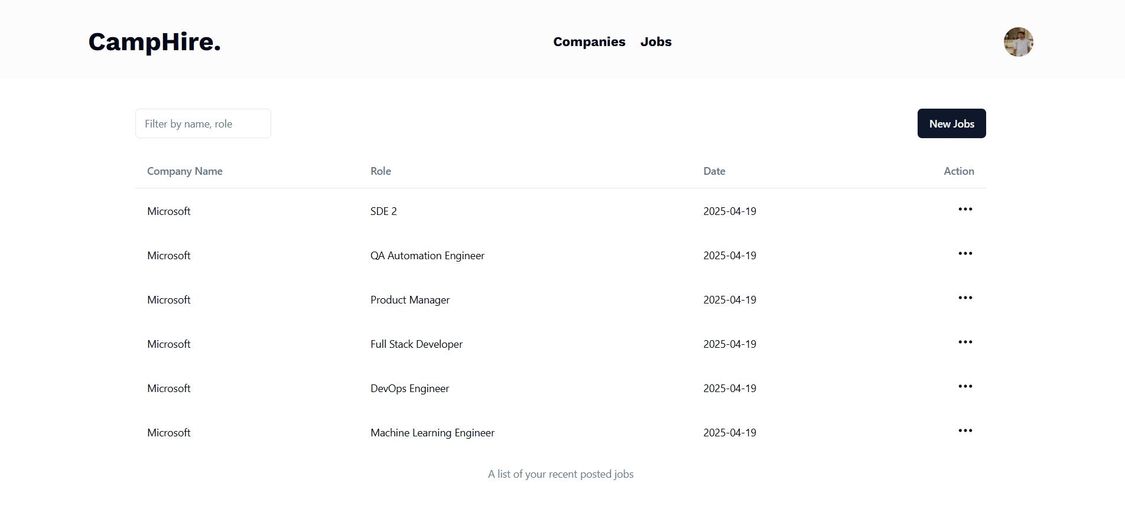

## 5.2 Observation

Throughout the implementation and testing phases of the CampHire project, numerous key observations were recorded that helped validate both the technical feasibility and usability of the platform. These observations reflect the system’s current strengths as well as potential areas for further improvement.

1. **Authentication and Authorization:**

The JWT-based authentication system functioned as expected, allowing secure login for both students and recruiters. Role-based access ensured that students could only view and apply for jobs, while recruiters were granted privileges to post listings and view applications. Unauthorized access to protected routes was properly restricted.

1. **Job Posting and Application Flow:**

The flow for creating job listings, viewing them on the frontend, and enabling students to apply worked seamlessly. Each application was correctly linked to both the job and the user profile, with proper timestamping and status tracking.

1. **Email Notifications:**

The system’s ability to send email notifications upon job posting or application status changes was validated. Notifications were received promptly and included relevant contextual information, helping streamline recruiter-student communication.

1. **User Interface Responsiveness:**

Developed with React and Tailwind CSS, the platform UI responded fluidly across various screen sizes, including mobile devices. All components adjusted properly without breaking layouts, ensuring accessibility for users across platforms.

1. **Database Operations:**

MongoDB proved reliable in handling user data, job listings, and applications. CRUD operations were executed efficiently, and data consistency was maintained even during concurrent interactions. Indexing and schema design supported fast retrieval times.

1. **Application Status Updates:**

Recruiters were able to update the status of applications, which reflected instantly on the student side. This confirmed the real-time synchronization between frontend state and backend data.

1. **Test Integration with Neo Platform:**

Although the system used an external Neo Platform for assessments, redirection and test link handling were successfully implemented. Students were able to access tests without error, and test completion was easily verified via external systems.

1. **Performance under Concurrent Usage:**

Initial scalability tests with 10–15 concurrent users applying and posting jobs simultaneously showed stable performance. However, further optimization may be required to maintain efficiency with significantly larger user bases or complex filtering queries.

1. **Error Handling and Feedback:**

All critical forms and actions included clear error messages and validation prompts. This improved the user experience by preventing form submission errors and ensuring required fields were completed properly.

1. **Data Security:**

Basic security features such as input sanitization, route protection, and secure password storage via bcrypt were in place and functioned as intended, offering a strong foundation for data protection.

## 5.2 Discussion

The development of **CampHire** offered a valuable opportunity to understand the complexities and practical challenges of building a real-world job portal using the MERN stack. The architecture was carefully designed to ensure modularity, scalability, and maintainability, which were critical in handling features such as user registration, job postings, application tracking, and email notifications.

**Technical Architecture & Benefits:**

The use of MongoDB, Express.js, React.js, and Node.js provided a consistent JavaScript environment across both frontend and backend, reducing context switching and simplifying integration. RESTful APIs enabled seamless communication between components, while Axios handled HTTP requests efficiently. Email services were integrated using Nodemailer, which allowed recruiters and students to receive real-time updates regarding application and selection statuses.

Security was prioritized by implementing JWT-based authentication and bcrypt for password hashing. This ensured secure access to user profiles and protected sensitive employer and student data. Additionally, role-based access was enforced, giving employers privileges to manage job listings and view applicants, while students could build their profiles, apply for jobs, and track application statuses.

**User Experience & Features:**

CampHire focused heavily on providing an intuitive and accessible experience. The user interface, built with Tailwind CSS, was responsive across devices and screen sizes. Key features included job listing filters, real-time application status updates, and a clean dashboard for both students and employers.

One of the standout elements was the integration of an external assessment platform (Neo), which allowed students to take skill tests after applying for jobs. Though not hosted internally, this bridged the gap between applications and evaluations, mimicking real-life hiring procedures.

**Collaboration & Workflow:**

The project supported asynchronous collaboration between employers and students. Recruiters could manage multiple postings, review applications, and mark statuses, while students had access to past applications and current opportunities. Email notifications ensured that communication gaps were minimized and important updates reached users promptly.

**Limitations & Areas for Improvement:**

While CampHire fulfilled its core objectives, several limitations were identified:

* Real-time assessments and evaluations were hosted externally; integrating an in-platform testing system would improve workflow consistency.
* The absence of resume or portfolio upload features limited the depth of student profiles.
* Skill match features based on keyword comparison were conceptualized but not implemented in the current version.
* Scalability for a larger user base will require backend optimization and possibly the use of tools like Redis for session handling or load balancing.

Overall, CampHire has laid a strong foundation for a modern job portal tailored to college environments. With further enhancements, it has the potential to evolve into a robust recruitment and placement ecosystem.

# CONCLUSION

The **CampHire** project represents an innovative approach to streamlining the campus recruitment process, offering a unified platform that bridges the gap between students seeking opportunities and employers scouting for fresh talent. Designed with a strong emphasis on enhancing user experience, providing seamless job application workflows, and integrating modern web technologies, CampHire caters specifically to the unique requirements of educational institutions and student-driven hiring ecosystems.

In today’s competitive environment, campus recruitment plays a pivotal role in connecting industries with emerging talent pools. Traditional recruitment methods, involving physical drives and scattered application processes, are often inefficient, time-consuming, and lack real-time coordination. CampHire addresses these challenges by creating a centralized digital platform where students can easily discover opportunities, and employers can efficiently manage and assess applicants.

CampHire integrates critical features like job posting, real-time notifications, student profiles, and application tracking. It eliminates the need for disjointed communications, enabling both parties to collaborate effectively in a digital-first manner. With secure authentication, smooth user flows, and transparent status updates, CampHire ensures that the recruitment process remains organized, user-friendly, and accessible.

The project also emphasizes the importance of skill-building and career preparation. By allowing students to register, showcase their skills, and apply directly through the platform, CampHire encourages proactive career development. Employers, on the other hand, gain access to a pre-verified pool of candidates, saving valuable time in the hiring pipeline.

One of CampHire’s standout features is its responsive and scalable design, making it accessible across a wide range of devices. Whether accessed from a desktop during a placement drive or a mobile phone while commuting, users experience consistent performance and ease of use.

**Challenges Faced**

Developing CampHire was not without its obstacles. Ensuring a secure and smooth real-time communication system, managing concurrent application submissions, and integrating reliable notification mechanisms posed significant technical challenges. Special attention was given to handling authentication, data integrity, and scalable backend operations to ensure a seamless user experience even under heavy load.

Additionally, balancing a clean, minimalistic interface with powerful administrative and student-side functionalities required thoughtful UI/UX design decisions. The team needed to prioritize essential features while leaving room for future enhancements.

**Future Prospects**

Looking ahead, CampHire holds immense potential. Planned future upgrades include adding skill-based test assignments directly within the platform, detailed analytics dashboards for recruiters, and student portfolio showcases to better match talent with employer expectations.

As CampHire continues to evolve, it is well-positioned to become a benchmark solution for campus recruitment processes, bridging gaps between academia and industry. With its user-centric design, strong technical foundation, and room for growth, CampHire is ready to make a lasting impact in the field of recruitment technology for educational institutions.

# FUTURE SCOPE AND FURTHER ENHANCEMENT OF THE PROJECT

### The CampHire platform successfully bridges students and employers through a streamlined, efficient recruitment process. However, there is significant potential for future improvements and expansions to enhance the platform’s functionality, usability, and reach. The following future scope and enhancements are envisioned:

### Integration of Skill Assessment Tests:

### Add coding challenges, aptitude tests, and domain-specific quizzes directly on the platform.

### AI-Based Candidate Matching:

### Use Machine Learning algorithms to automatically suggest the best candidates for job postings based on skills and profiles .

### Resume Builder and Portfolio Integration:

### Provide an in-app resume builder and allow students to upload or link their portfolios and certifications.

### Advanced Notification System:

### Introduce SMS, WhatsApp, and detailed in-app notifications for real-time application and interview updates.

### Employer Dashboard Enhancements:

### Offer detailed analytics like applicant tracking, skill distribution, interview stages, and customizable filtering options.

### Video Interview Integration:

### Integrate live and one-way video interview options directly within the platform to simplify screening processes.

### Cloud Storage Integration:

### Store important documents (resumes, ID proofs, offer letters) securely using cloud solutions for easier access.

### Mobile Application Development:

### Build dedicated Android and iOS applications for seamless mobile access, job applications, and notifications.

### Enhanced Security Features:

### Implement Multi-Factor Authentication (MFA), end-to-end encryption, and GDPR-compliant privacy practices.

### Multi-Institute Support:

### Enable multiple colleges/universities to use CampHire with separate administrative controls for each institution.

# BIBLIOGRAPHY

**Web Resources**

1. Mozilla Developer Network (MDN). "JavaScript Documentation." <https://developer.mozilla.org/en-US/docs/Web/JavaScript>
2. React Documentation. "Getting Started with React." https://reactjs.org/docs/getting-started.html
3. Express.js Documentation. "Express Guide." <https://expressjs.com/>
4. MongoDB Documentation. "MongoDB Manual." <https://www.mongodb.com/docs/>
5. Node.js Documentation. "Node.js Docs." https://nodejs.org/en/docs/
6. Tailwind CSS Documentation. "Utility-First CSS Framework." <https://tailwindcss.com/docs>
7. JWT.io. "JSON Web Token Introduction." https://jwt.io/introduction
8. Nodemailer Documentation. "Send Emails from Node.js." https://nodemailer.com/about/
9. GitHub. "GitHub Documentation." <https://github.com/>
10. Vercel Documentation. "Deploy Frontend Applications." https://vercel.com/docs
11. Render Documentation. "Host Backends with Render." <https://render.com/docs>

**Books**

1. Haverbeke, Marijn. *Eloquent JavaScript: A Modern Introduction to Programming.* 3rd ed., No Starch Press, 2018.
2. Banks, Alex, and Porcello, Eve. *Learning React: Functional Web Development with React and Redux.* O'Reilly Media, 2017.
3. Cantelon, Mike, et al. *Node.js in Action.* 2nd ed., Manning Publications, 2017.
4. Chodorow, Kristina. *MongoDB: The Definitive Guide.* 2nd ed., O'Reilly Media, 2013.